CHAPTER 1 INTRODUCTION OF THE STUDY

Background of the Study and Theoretical Framework

Color is one of the factors that contribute to the life of any object. Color defines any distinctive features, whether it is a drawing, a film, an animation, or the environment around us. The eyes aid in the perception of these colors. The colors are the first thing that someone notices when they look at a piece of art. However, if the eyes are damaged in any way, whether physically or chemically, or as a result of inherited genes from the parents, faulty photo pigments in the eyes will result in color deficiency or color blindness (WebMD, 2021). According to Colourblindawareness.org (n.d.), this illness affects 1 in 12 men (8%) and less than 1% of women. Color blindness has no known cure unless it is caused by certain medicines or eye conditions, but this does not stop color-blind people from leading normal lives. Color-blind people can do almost everything that a "non-color-blind" person can, but there are some drawbacks. Color blindness affects people's ability to distinguish colors as they should, which can limit their access to education, hobbies, and career options. Color blindness, moreover, prevents people from fully appreciating movies and other forms of entertainment. Today, thanks to technological advancements, there are glasses and contact lenses that assist people in distinguishing between colors. Color-blind accessibility has also been considered in video games, with filters on the screen and customizable colors for important information. What about movies, though? Sure, some glasses could aid in color perception, but not everyone could afford such costly glasses.

Although it is a lesser-known aspect of the film, color is used to propel and convey the plot, according to May (2017), a TED.com writer. During the planning process, filmmakers considered the color schemes that would be used in each frame. This was done to influence the viewers' viewing experience without them realizing it. May (2017) went on to say that color simplified complex stories, made the audience feel, showed the character's journey, and communicated a film's ideas. Color-blind people were at a disadvantage in this situation because their condition prevents them from distinguishing colors. As a result, using colors in movies to convey a much deeper narrative to the story would be ineffective for them. The result of this study would help people who were color-blind understand and distinguish the colors in the film. The short film discussed color-blind people's experiences, different types of color blindness, love, and friendship. The goal of this study, Hues of You: A 2D Interactive Animated Short Film, was to create a 2D interactive animated short film that would be color-blind friendly.

Objectives of the Study

This study aimed to create a 2D interactive animated short film that was color-blind friendly.

Specifically, this study aims to:

1. Create a two-dimensional animated short film that highlighted the peculiarities of two-dimensional people and objects while also being color-blind-friendly for various degrees of color-blindness (Protanopia, Deuteranopia, and Tritanopia).

2. Create an interactive system in the short film that allowed the viewer to select his or her color blindness type, offered preset color palettes for all types of color blindness, and modified the color palette of the characters and objects based on the viewer's color blindness type.

3. Identify key scenarios for color-blind people through data gathering and integrate them in the story of the short film.

4. Develop a viewer evaluation module within the interactive media system to determine the film's effectiveness as a color-blind-friendly film.

Significance of the Study

This study aimed to create a 2D interactive animated short film that was color-blind and friendly to different types of color-blind (Protanopia, Deuteranopia, and Tritanopia). This is significant to the following:

*Color-blind People.* Because they could not see colors the way they were, this study would greatly aid their understanding of the film.

*Non-Color-blind People.* This study would expose them to what a color-blind person could see. This would also aid them in determining the causes of color blindness.

*Filmmakers.* This study would benefit future filmmakers who wanted to include color-blind accessibility in their films.

*Future Researchers.* This study would be significant for those who intended to conduct similar or related research because they would use this study as a foundation and a reference to make their research much more understandable and clearer.

Definition of Terms

For better understanding, the following terms were defined conceptually and operationally:

*2D Animation*. Characters and backgrounds are created in a two-dimensional, flat space in 2D Animation or Two-Dimensional Animation. Height and width are the only properties of 2D animation objects; there is no thickness. They are either hand-drawn or computer-generated (darvideo.tv, n.d.).

In this study, 2D animation was used on the characters and objects within the short film.

*Color Blindness.* Color blindness, also known as a color deficiency, is a type of visual impairment in which a person's perception of color differs from that of others. Color-blind people have trouble distinguishing between different colors (National Eye Institute, 2019).

In this study, Color Blindness was used as a topic for the short film. The short film was also color-blind-friendly for those who were color-blind.

*Deuteranopia*. Deuteranopia is a type of red-green color blindness in which the ability to distinguish between red and green pigments is impaired. People with deuteranopia are unable to perceive green light, causing red and green colors to appear murky (healthline.com, n.d.).

In this study, the film included a color palette for the Deuteranopia type of color blindness, which meant that people with this type of color blindness will have no trouble distinguishing between the colors red and green.

*Interactive.* Allowing a two-way flow of data between a computer and the user, as well as responding to the user's input (Hadkins, H., & Lewis, S. (2011)).

In this study, the film used interactivity to allow the viewer to select his or her color blindness type, provide preset color palettes for all types of color blindness, and adjust the color palette of the characters and objects based on the viewer's color blindness type. For additional guidance and information, an interactive questionnaire about color blindness was also added.

*Protanopia.* A type of color blindness in which a person is completely unable to distinguish between the colors red and green. People who have this type of color blindness are unable to perceive red light, causing green colors to appear murky (gamersexperience.com, n.d.)

In this study, the film included a color palette for the Protanopia type of color-blindness, which means that people with this type of color-blindness would have no trouble distinguishing between the colors red and green.

*Tritanopia.* A type of color-blindness in which a person has trouble distinguishing between blue-related colors. Tritanopia is the inability to perceive blue colors, which causes greens to appear murky and red colors to appear pink (gamersexperience.com, n.d.).

In this study, the film included a color palette for Tritanopia, which meant that people with this type of color-blindness would have no trouble distinguishing between blue-related colors within the film.

Delimitation of the Study

This study entitled “Hues of You: A 2D Interactive Animated Short Film” aimed to create a 2D interactive animated short film that was color-blind friendly. This study focused only on making a 2D film that will highlight the characteristics of 2D characters and objects. This study only focused on making interactivity within the film that allows the viewer to choose what kind of color blindness they have, so the film’s colors can adjust to the color blindness type chosen by the viewer. There is also be a viewer evaluation module within the interactive media system to determine its effectiveness for color-blind individuals, this evaluation module will only have 10 questions in total. The score at the end will be shown to the viewer, the score determines the effectiveness of the film. The researchers only used three types of color blindness in this film namely, Protanopia, Deuteranopia, and Tritanopia, the other type of color blindness which is Monochromacy, was not included in the study. Another color palette was also made for the “Non-Color-Blind” viewers. The movie only lasted for approximately 4-9 minutes.

CHAPTER 2 REVIEW OF RELATED STUDIES

Review of Existing and Related Studies

*A. Animated Film about Color Blindness*

Color blindness was not well-represented in animated films. There were some informative animations about it, but few of those animations portrayed the tale of a person who had this sickness. This was one of the reasons why some individuals were not fully aware of how color blindness affects an individual. The researchers did, however, discovered an animated film about color blindness and how it might influence a person. Ishihara was the name of the film.

In an interview with Yoav Brill by Kirn (2010), Ishihara as an exploration of color blindness that told the story entirely in dots. Brill intended for this film to be a moving examination of differences. Brill kept the color palette's saturation low in this film so that "non-color-blind people" viewers would have a hard time distinguishing the colors.

The researchers of this present study would also apply the same narrow saturation to the interactive animated film's color palette. The researchers would also create different palettes for each type of color blindness that the viewers choose (Protanopia, Deuteranopia, and Tritanopia).

*B. Color Correction*

Color correction is the process of editing each video clip to match a standard appearance. The problems within a color were resolved in this process by balancing out the colors and ensuring that everything was even. Color correction aimed to match video clips to a standard that was an accurate representation of how the human eye would see it (sneakybig, n.d.).

The film documentary entitled “Sight: The Story of Vision” was the first ever film that had its color adapted for color-blind people. Kris Koenig, the writer and director of the film, applied a color correction to the film for the color blind, according to news provided by Koenig Films, Inc. to the PR Newswire. When Koenig tried on a pair of EnChroma glasses, which were designed to help with color blindness, the director got the idea. In this film, Koenig used the color-blind accessible correction to help viewers with limited red-green color sensitivity see the differences between colors that they would normally struggle to see. The researchers would still use color correction in this study, but it would be applied to all types of color blindness, not just red-green color blindness, Protanopia, and Deuteranopia. The researchers also included an interactive system in the film that would allowed viewers to select their type of color blindness, allowing the entire color of the film to adjust to their preference.

*C. Color-Blind Accessibility*

Color Blind Accessibility in web design, according to siteimprove, aids in lowering the barrier to entry for users with color deficiency. Color-blind accessibility refers to the design of elements within a website to assist people with this deficiency in using and experiencing the website as expected.

Games also started to add some color-blind accessibility, to help gamers who suffer from a color deficiency. Hardin (2016) looked at some of the games that were designed with color-blind accessibility in mind. Hardin stated in this review that there were three approaches to color-blind accessibility in games: filters, customizable colors for information, and iconography as a supplementary conveyance. The whole screen filters, according to Hardin, were not the best approach for two reasons: one, color-blind people saw a limited range of color, and two, changing all of the game's colors to those that were only distinguishable by color-blind people made the game look bizarre and unnatural. Hardin also stated that allowing players to customize the colors for critical information was the best approach. He also believed that incorporating iconography as a secondary mode of communication helped players. According to Hardin (2016), it was critical that vital game information not be conveyed solely through colors, as this would negatively impact the experience of color-blind players.

In this study, the researchers incorporated an interactive system into the film that allowed viewers to to select their color blindness type and be presented with a pre-selected color palette.

*D. 2D Interactive Story and Animation*

The art of creating characters, backgrounds, and effects in a two-dimensional space is known as 2D animation (cgspectrum, n.d.). The term "interactive" refers to a two-way electronic communication system that includes a user's orders or responses (Merriam Webster Dictionary, n.d.).

Yu (2015) investigated how designing an interactive storytelling application could help elementary school children become more aware of color blindness. The researcher created an interactive storytelling application for elementary school-aged children in this study, "See a Different World: Interactive Storytelling for Children to Raise Awareness of Color Blindness." The application was created by the researcher for children to learn about color blindness by reading and playing games. A short color blindness test was also included in the application for the kids. The researcher also ensured that the application's visuals would attract children's attention by making them colorful.

In 2014, Coldplay released a music video for their fourth single “Ink” from the album "Ghost Stories". The band collaborated with the agency Blind to create an interactive story about a lost traveler who traveled to the ends of the earth in search of his long-lost love. Blind's creative team collaborated with an interactive team in New York to work on the story's interactivity, according to Matthew Encina, the interactive story's creative director. The video's interactivity was created using the custom Treehouse platform from Interactive specialist Interlude. The team devised a system of buttons to guide viewers through the experience of the video.

In this present study, instead of creating an interactive storytelling application, the researchers created an interactive animated short film about color-blind people's experiences, color-blind types, and love. The interactive animated film would also allow viewers to select which type of color blindness they have, and the color composition of the film will change based on their selection.

CHAPTER 3 RESEARCH DESIGN AND METHODOLOGY

Description of the Proposed Study

This study entitled “Hues of You: A 2D Interactive Animated Short Film” aimed to create a 2D interactive animated short film that was color-blind friendly. The researchers created an interactive short film where the viewer could choose what type of color blindness they had, and the composition of the whole film would change based on what type of color blindness the viewer chose. The film would also had a viewer evaluation module while the film progresses to determine the film's effectiveness for color-blind individuals.

For the film's interactivity, the researcher’s utilized Unity Game Engine. The illustrations, such as characters and backgrounds, were created in Adobe Photoshop. For the animation, the illustrations were imported to Clip Studio Paint. After that, the animated scenes were assembled and integrated into DaVinci Resolve 17 for color grading, and Adobe Audition was utilized to create the background music, sound effects, and voiceovers. The interactive animated film would begin with a choice for viewers to select whatever form of color blindness they had, as well as a choice for non-color-blind viewers. The film's color would then adapt to match the viewer's preference. At the end of the film, there are questions provided for the viewers to determine whether the film is effective for color-blind individuals or not. The scores that the viewer got will be shown. This would determine whether or not the film was effective for color-blind individuals. This research would particularly help color-blind people who had trouble determining the colors of a normal film. Like in games, the researchers incorporated color-blind accessibility within the film.

Methods and Proposed Enhancements

Animated films have long been a source of entertainment for people. Other styles of animation exist, but 2D animation is the most common and one of the oldest. This animation is used to generate flat 2D people and environments. In today's world, interactive media is critical. Interactivity not only makes a person more active, but it also makes it easier for them to communicate with others. Interactivity also enables the free flow of information and ideas.

The 2D Interactive Animated Short Film’s development is discussed in this section, which includes the system architecture used, the animation production process, the activity diagram, and the system life cycle.

The components of the Interactive Animated Short Film System Architecture are: (1) the viewer, who is the primary beneficiary of the film; (2) viewer input, which includes the data inputs available during the film's execution; (3) display device in which the visual information will be shown; (4) a graphical user interface (GUI) is a set of computer-based interactive visual components; (5) unity game engine that consists of animated film sequences, pre-selected color palettes, and color graded film. The animated short film interactive system was composed of the color-blind option in which the viewers would choose what kind of color blindness the viewer had, the viewer evaluation module which would appear at the end of the film, and the evaluation score which would determine the effectiveness of the interactive system and the color palette of the film for color-blind people.

The animation production process was composed of Pre-production, Production, and Post-Production. Under the Pre-production, the storyline planning; concept art which included: props and environment design, environment color art, character line art, and character art; storyboarding which included: scene backgrounds, camera movement and frame perspective, lighting and character staging, and mood and atmosphere. The production stage included Rough animation, which was composed of; frame set-up and perspective, VFX line art, line art correction, clean-up; in-betweening, and frame-by-frame digital painting. Then lastly the Post-production was composed of: audio effects processing, which included; Foley sound effects and background ambient sound effects; cut and duplicate cut scenes, implementing color spectrums, merging animation sequences of each different color-blind type, and lastly review workflow.

The dynamic elements of the film's interactive system were depicted in the Activity Diagram. It showed the flow of activity between the viewer and the interactive system of the film. First, the viewer would open the film (in a form of apk). Then the player was offered an option to choose between three color-blind types and one for non-color-blind people. The interactive system loaded the color-graded film and displayed it for the viewer to see. Then, at the end of the film, a viewer evaluation module would appear and the viewers would answer them, the scores gathered from the evaluation module will then be shown after. The viewer would either end or replay the film and choose another color-blind option.

For the System Development Life Cycle, the Agile life cycle is applied. The agile life cycle is a set of stages that a product goes through as it progresses from start to finish. With this format with the use of Agile methodology, the content represents the phases of overall development in a circular motion. Representing the continuous process of planning, executing, and evaluating. Planning before the actual production is a universal norm, therefore the team must have prepared the basics and foreground rules to implement in the production cycle, in essence, the team must have a planned and proper development process that includes the overall phases to detailed topics to perform in the workflow. If the planning phase seems to be approved and/or suitable, the team must move to the design phase. This part is where the team must assume the layouts and affairs of what is in the project. These circumstances involve drafting a plot and possible characterization. The team must craft theories and debate on which options are fitting to the theme and core of the project.

The Development phase contained the production part of the project, the team is engrossed most in the task during this phase for this covers the continuous animation processes and having equipped with additional external software for the final quality. While it's in development, the team can proceed to test the quality flow of the animation. The team must resolve issues and other flaws, simultaneously, the outline of the project can be traced back and re-edit that setting to enhance the motion. During the continuous examination of the sequence animation, the team can give a test preview of its outline and flow to carry out its polished upgrade. In the same phase, the crew can perform the final rendering of the whole project sequence.

Right after rendering, the project undergoes User Evaluation. This included having live tests of the project for representatives who participated. The feedback or review was noted for insights. Possible major flaws after multiple surveys might be traced back and redone or append those particular circumstances and continue the life cycle until it reaches the point of satisfaction.

The final phase is to launch the project to the world, this is an emblem that the product is wholly done and awaiting its viewer’s reaction and experience.

Few films are designed for color-blind people. In terms of color-blind accessibility, films are certainly lagging. Game developers have already incorporated color-blind accessibility within their game’s system, considering the color-blind people who play games. But, the film industry still hasn’t put this deficiency into consideration. This study will help with this problem. Putting interactivity within the film will allow the viewer to choose a type of color blindness and the color composition of the film will change based on the chosen color blindness. The film also offered a viewer evaluation module, which will appear at the end of the film. The score of the viewer evaluation module will be shown at the end to determine whether the film is effective for color-blind people or not. With this, the viewer can enjoy a film where the viewer can differentiate the color inside the film.

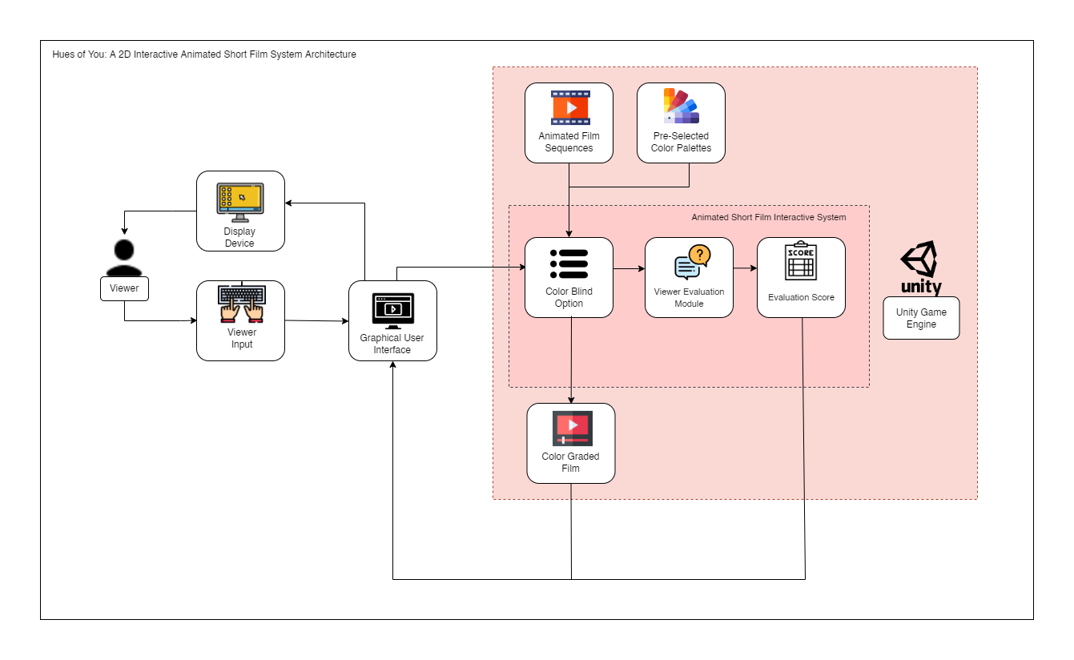Components and Design

**Figure 1.** System Architecture of the Interactive Animated Short Film

Figure 1 shows the conceptual model for the system architecture of the interactive system of the film and the process of how it works. The development of the interactive system of the film consists of the following components, as shown in figure 2.

1. Viewer: the primary beneficiary of the film.
2. Viewer Input: includes the data inputs available during the film's execution.
3. Display Device: in which the visual information will be shown.
4. Graphical User Interface: a set of computer-based interactive visual components.
5. Unity Game Engine: The main development software utilized for the animated film’s interactive system.

The following components make up the game engine used in the film:

1. Animated Film Sequences: these animated film sequences were imported into the game engine.
2. Pre-selected Color Palettes: these color palettes were set in the film using the game engine.
3. Color-Graded Film: The game engine showed the color-graded film for whatever the viewer chose after selecting a color-blind type.
4. Animated Short Film Interactive System: this is where the viewer’s interactivity within the film happened. It is composed of:
5. Color Blind Option: in which the viewers chose what kind of color blindness the viewers have.
6. Viewer Evaluation Module: appeared at the end of the film. Helped in evaluating whether the film is effective for color-blind individuals.
7. Evaluation Score: the evaluation score determined whether the film is effective or not.

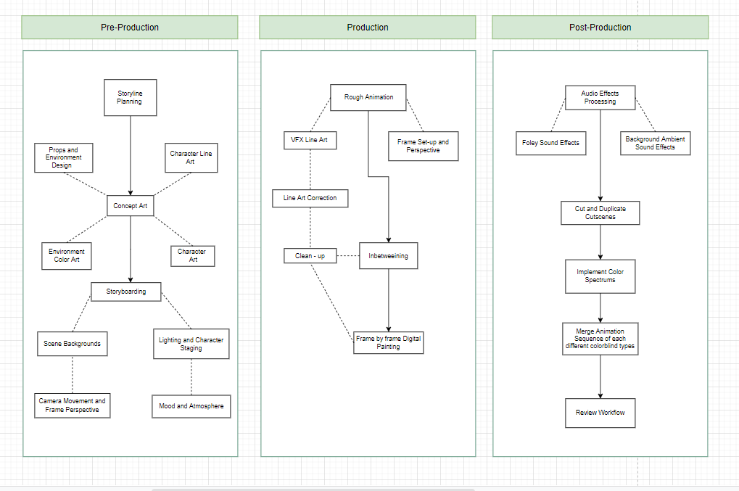**Figure 2:** Animation Production Process

The Animation Production Process shown in figure 2 illustrates the process of making the animation. It consists of:

A. Pre-Production

1. Storyline planning: the researchers first thought of what will be the main topic or story of the film.
2. Concept art: the researchers planned the characterization of the characters, how would the character look like, what would the gender of the character be, what would the attitude of the character be, what deficiencies of the characters were.
   1. Props and Environment Design: designing the props and environment inside the animation.
   2. Environment Color Art: painted the environment.
   3. Character Line Art: created the character line art.
   4. Character Art: created the character.
3. Storyboarding: the researchers created a storyboard to help in visualizing the animation and to communicate ideas clearly.
4. Scene Backgrounds: created the scene backgrounds.
5. Camera Movement: created the camera movement within the film.
6. Frame Perspective: visualizing the frame perspective of the scenes.
7. Lighting and Character Staging: created the lighting and character staging.
8. Mood and Atmosphere: created the mood and atmosphere of the scene.

B. Production Stage

1. Rough Animation: created a rough animation of the key poses in the storyboard.
2. Frame Set-up and perspective: setting up the frames and perspective.
3. VFX Line Art: created the line art for the VFX.
4. Line Art Correction: corrected the line art of the animation.
5. Clean Up: cleaned up the line art.
6. In-betweening: used to smoothen out the animation.
7. Frame-by-frame digital painting: the illustrations are painted.

C. Post Production

1. Audio Effects Processing: audio that was used in the film is processed.
   1. Foley Sound Effects: reproduction of everyday sound effects put into the film.
   2. Background Ambient Sound Effects: ambient sound effects are created and put into the film.
2. Cut and Duplicate Cutscenes: scenes are cut and duplicated.
3. Implement Color Spectrums: the film is implemented with color spectrums.
4. Merge Animation Sequence of each Color-Blind Type: the animation sequence of each color-blind type merged.
5. Review Workflow: the end product is reviewed.

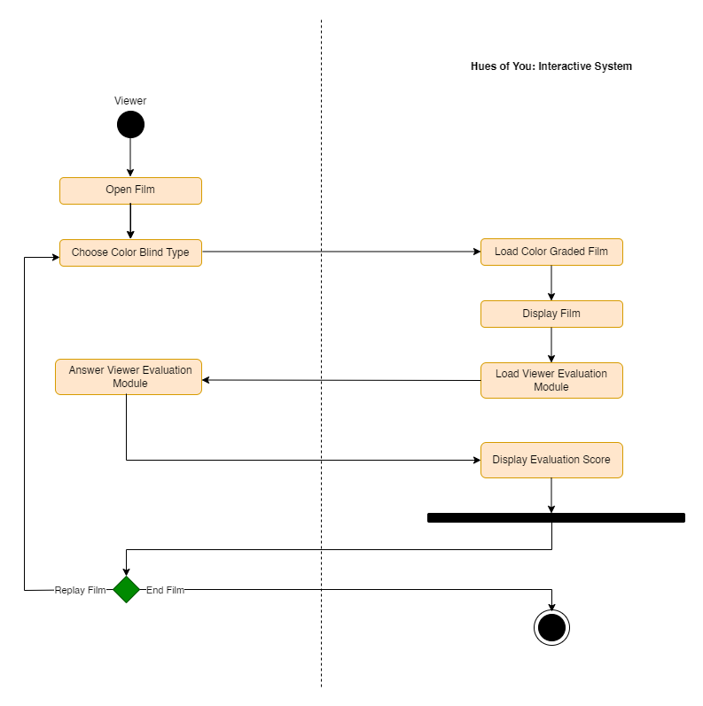

**Figure 3:** Activity Diagram

The activity diagram shown on figure 3 illustrates the interaction between the viewer and the film.

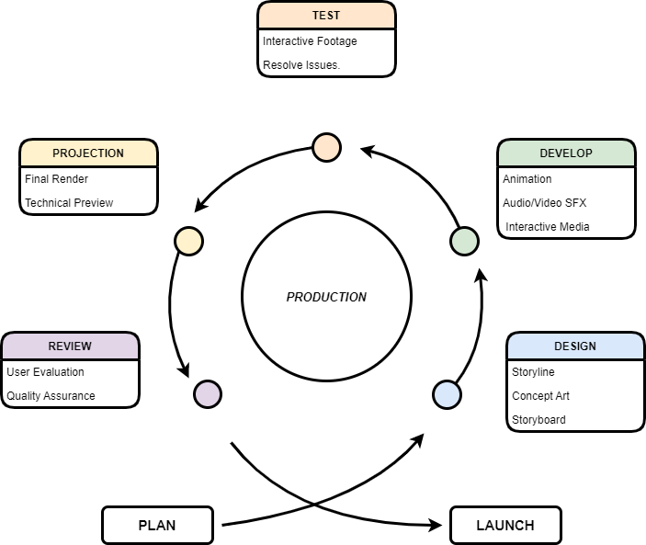

**Figure 4:** System Life Cycle

The Agile life cycle is used for the System Development Life Cycle as shown on figure 4. The agile life cycle refers to the stages that a product goes through as it develops from conception to completion. The content represents the phases of overall development in a circular motion using this format and Agile methodology. Representing the ongoing planning, execution, and evaluation process. This study benefited from it because there was fewer changes to the animation sets before the interactive system is created.

CHAPTER 4 RESULTS AND DISCUSSION

Implementation

The implementation of Hues of You: A 2D Interactive Animated Short Film is covered in depth in this section of the Results and Discussion. This included the pre-production, production, and post-production phases of the animated movie.

Pre-Production

One of the objectives of this study is to identify key scenarios for color-blind people through data gathering and integrate them into the story of the short film. The researchers interviewed five (5) people with color-blind disabilities. The results of these interviews are then integrated into the story of the film. The researchers also interviewed an optometrist in order to validate the data that the researchers gathered from references and the data that will be integrated into the script.

The researchers then wrote an original story that revolves around Timothy or Tim for short (the main character of the story), a person who suddenly acquired color blindness after an accident. The story showed what it feels like to have color blindness, the sudden loss of passion for something one loved, the setbacks of having color blindness and acceptance of one’s disabilities.

After planning what the film’s story would be about, the researchers then began with the pre-production phase of the development of the short film. It comprises storyline planning, character art, concept art, props and environment design, storyboarding, scene backgrounds, camera movement, frame perspective, lighting and character staging, and mood and atmosphere.

The storyline planning is the first step in creating the animated film. The researchers first brainstormed on what will be the concept of the whole film. The researchers involved then proceeded to think of the story and wrote a script for it. Planning the story flow of the film beforehand helps in establishing the significance of each character and creates an outline. After the planning of the concept, the making of the script is next. When the script is done the artist then starts to design the characters. Props and environment design, storyboarding, scene backgrounds, camera movement, frame perspective, lighting and character staging, and mood and atmosphere are included in this step. The researchers used raw photographs of places (taken from the internet and by the researchers) as references to create the environment within the animation. The researchers used Adobe Photoshop to create the character design and environment design that will be used in the film.

**Figure 5:** Screenplay of Hues of You 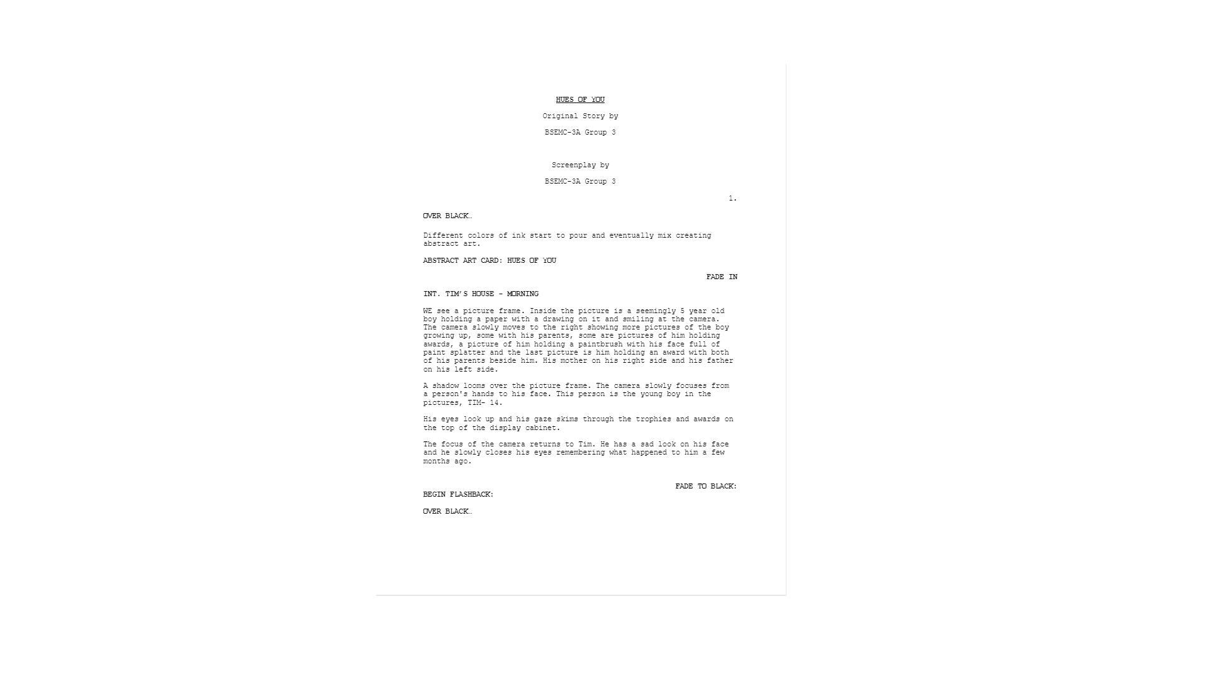

The figure above shows the first scene of the screenplay of the short film Hues of You.

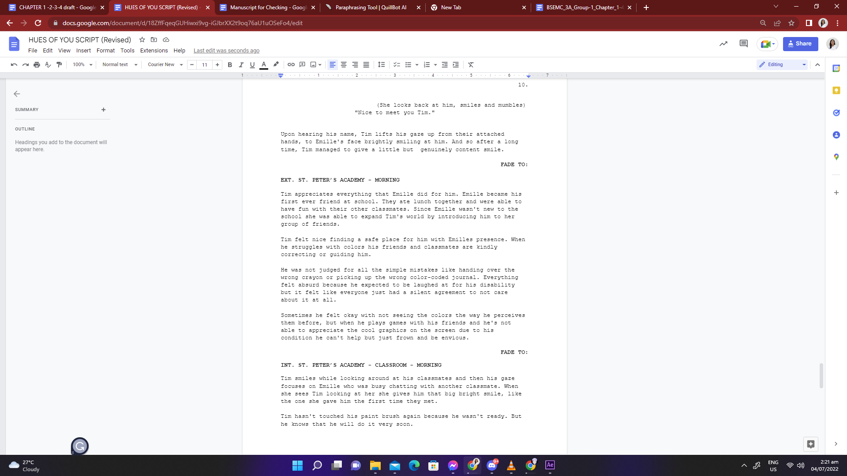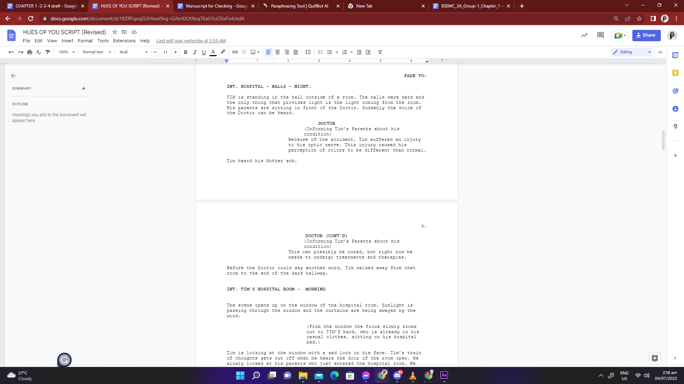

**Figure 6:** Screenplay of Hues of You that is integrated with the results of the interview.

The above figure shows some parts of the script that have been integrated with the results of the interview with color-blind people and an optometrist.

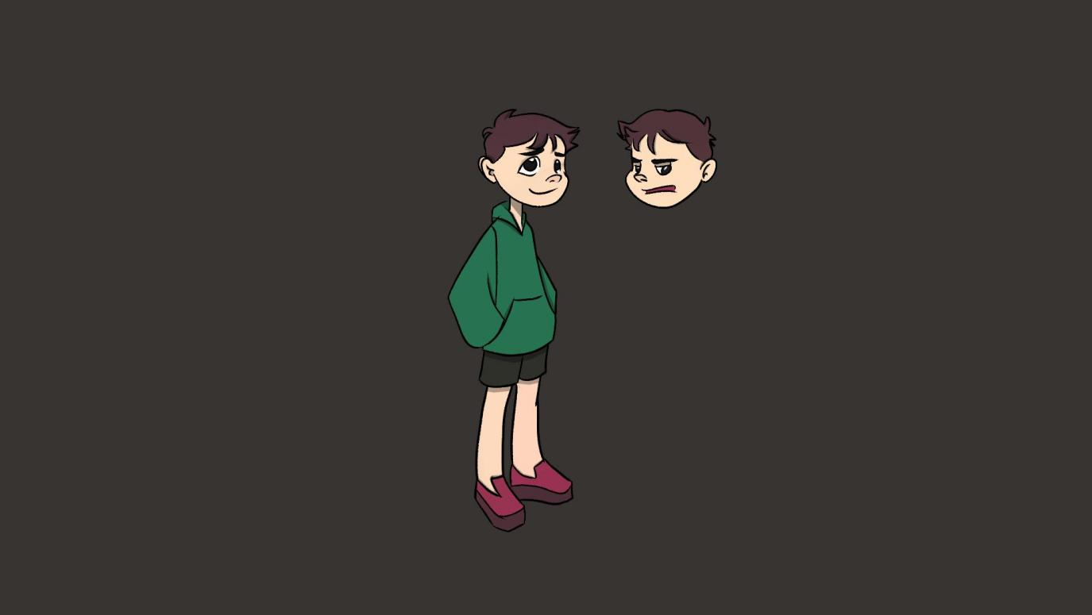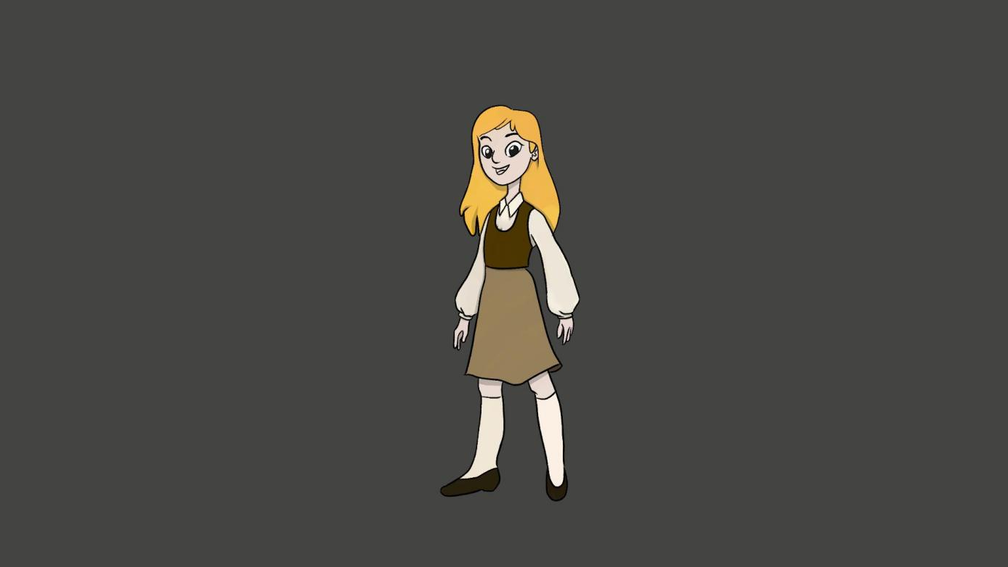

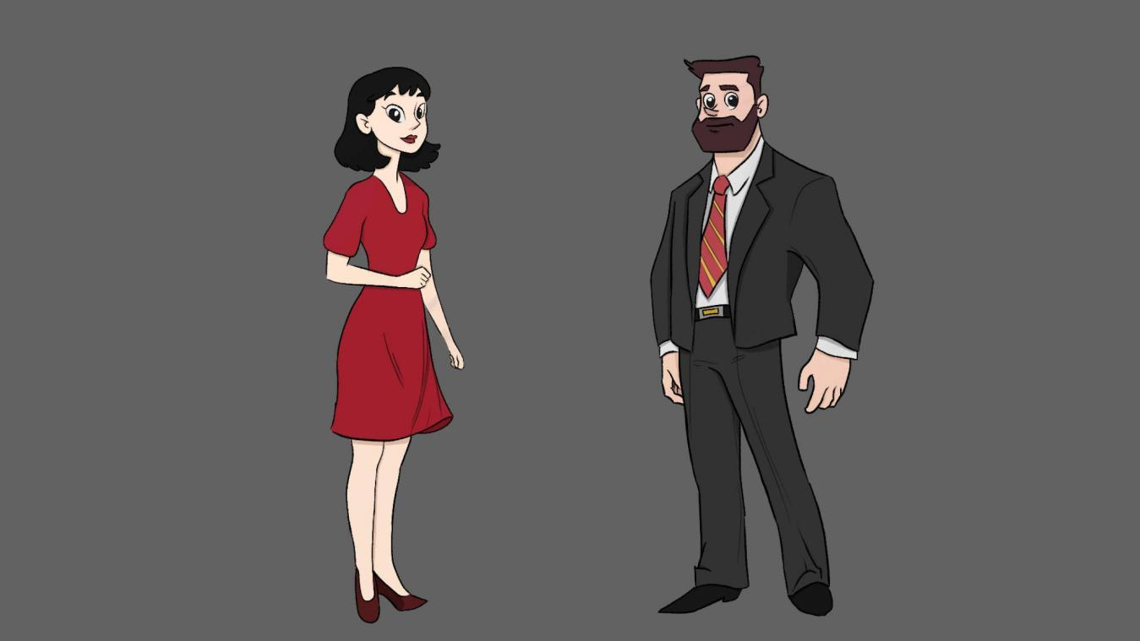

**Figure 7:** Character Designs

The figure above shows the design of the characters in the film.

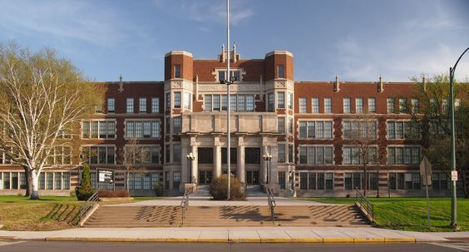

**Figure 8:** Raw Photographs

The figure above shows the raw photographs that was used as a reference for the background of the film.

Production

This section contains the production process of the short film. The objective that is to be achieved in this section is: Create a two-dimensional animated short film that highlights the peculiarities of two-dimensional people and objects while also being color-blind-friendly for various degrees of color-blindness (Protanopia, Deuteranopia, and Tritanopia). The short film’s production starts with the following: Rough Animation, Frame Set-up and perspective, VFX Line Art, Line Art Correction, Clean Up, In-betweening, and Frame-by-frame digital painting.

In order to execute these steps, the researchers used Clip Studio Paint. Assets (such as props and environment design, character design etc.) created from Adobe Photoshop are transferred to Clip Studio Paint for the animation process.

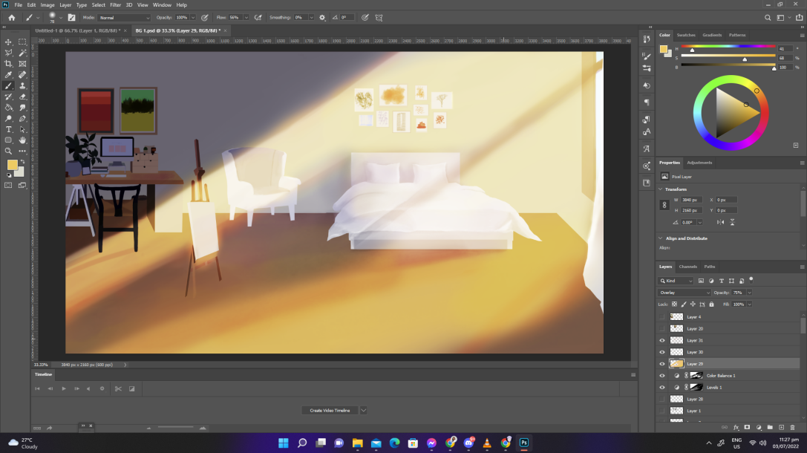

**Figure 9:** Creating Environment Design Using Adobe Photoshop

Figure 9 shows the creation of the environment design in Adobe Photoshop.

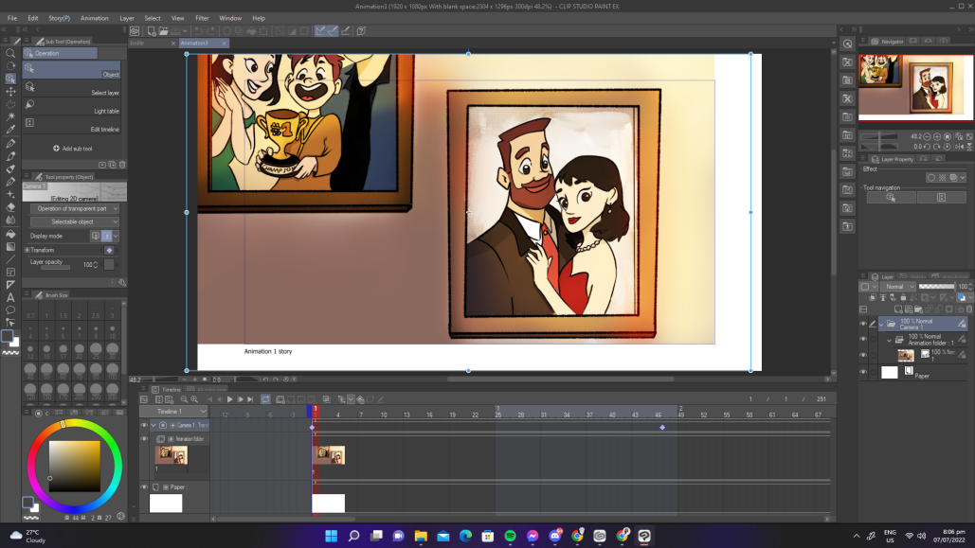**Figure 10:** Animation in Clip Studio Paint

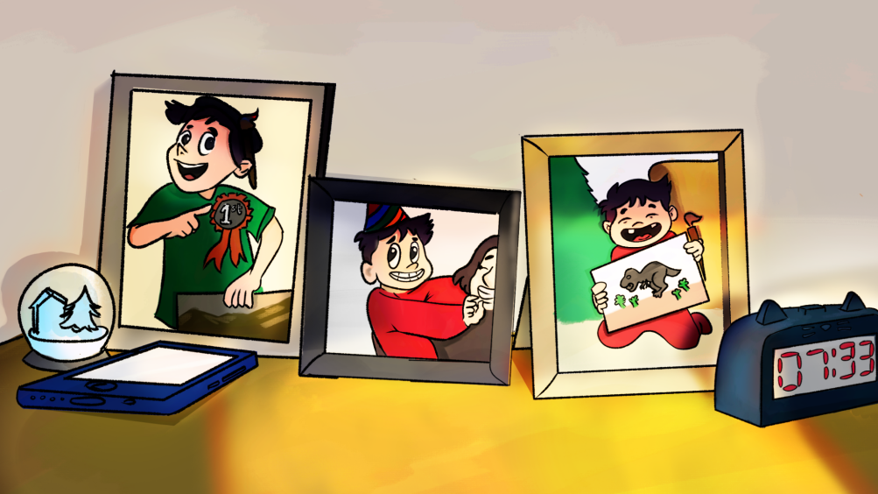Figure 10 shows the animation process in Clip Studio Paint.

**Figure 11:** Lighting in Photoshop

Figure 11 shows the addition of lighting in Adobe Photoshop.

Post-Production

In this section, the final touches that were added to the film were made. The objectives that were achieved in this section were: Created an interactive system in the short film that allowed the viewer to select his or her color blindness type, offered preset color palettes for all types of color blindness, and modified the color palette of the characters and objects based on the viewer's color blindness type, and developed a viewer evaluation module within the interactive media system to determine the film's effectiveness as a color-blind friendly film.

Audio Effects Processing, Foley Sound Effects, Background Ambient Sound Effects, Cut and Duplicate Cutscenes, Implement Color Spectrums, Merge Animation Sequence of each Color-Blind Type, and Review Workflow were the overall process. After making the animation in Clip Studio Paint, additional effects were added using Adobe After Effects and Adobe Premiere Pro. The animation transferred to Davinci Resolve 17 for the implementation of color spectrums. When these additional effects to the animation are added, sound effects and background music are then created using Adobe Audition. The animation sequences that are implemented with color spectrums are then merged. When all of these are finished, the researchers start with the creation of the interactive system of the short film using Unity- a real-time development platform. The programming language that was used in Unity is C#. All of the languages used by Unity are object-oriented scripting languages. Scripting languages, like any other language, include syntax, or parts of speech, with the key parts being variables, functions, and classes. The merged animation sequences are transferred to Unity for interactivity within the short film. The short film's effectiveness for color-blind viewers is then determined by the viewer evaluation module, which is developed at the conclusion of the movie.

The researchers will then review and test the interactive system and the animation if some irregularities need to be fixed immediately.

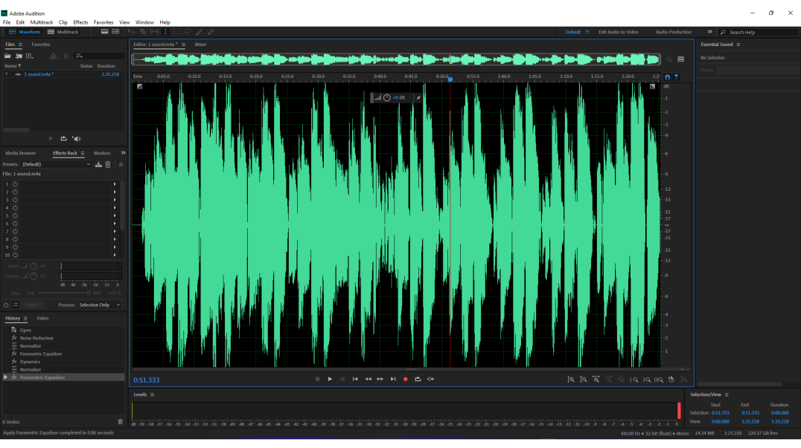**Figure 12:** Editing Music using Adobe Audition

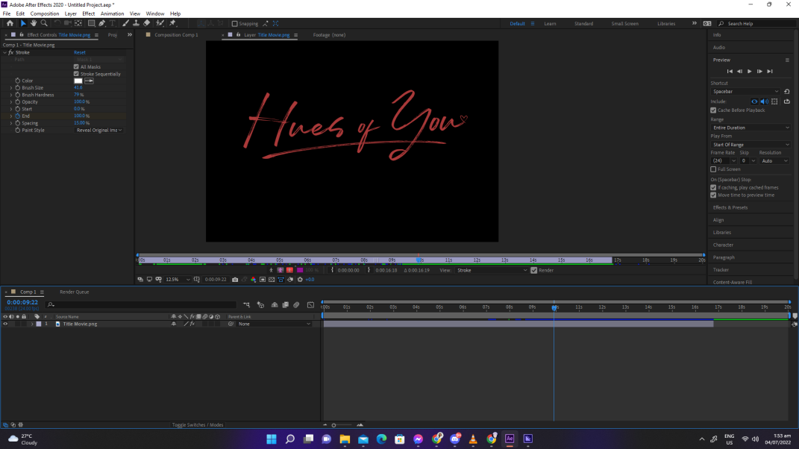Figure 12 shows the editing of the music that will be used in the film using Adobe Audition.

**Figure 13:** Adding additional effects in Adobe After Effects

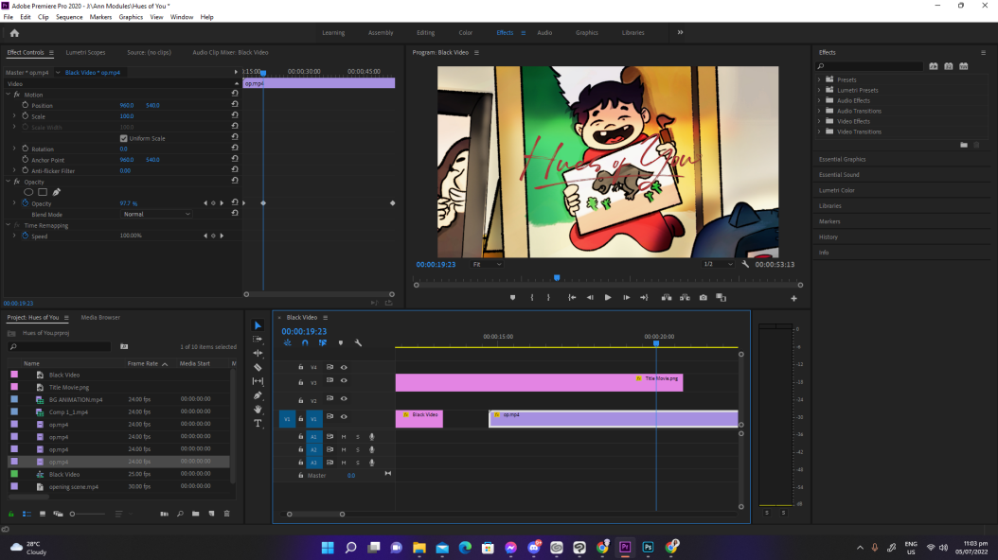Figure 13 shows adding some effects to the animation in after effects.

**Figure 14:** Editing in Premiere Pro

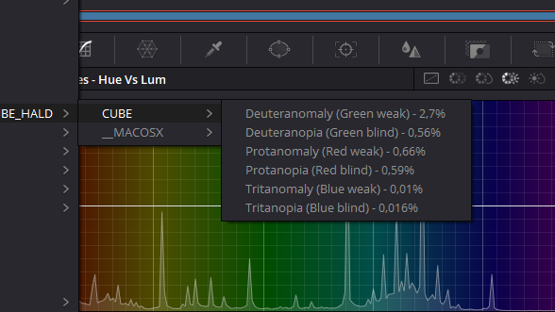Figure 14 shows the editing process of the animation scenes in adobe premiere pro.

**Figure 15:** Color-blind Adjustments within Davinci Resolve

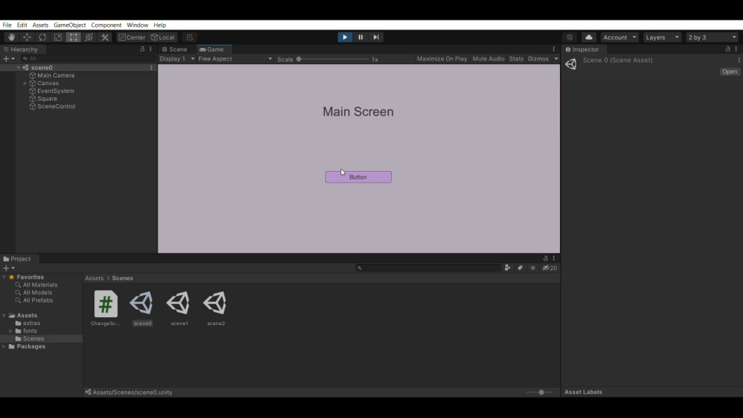Figure 15 shows the adjustments that are added to the animation that has been edited in premiere pro in Davinci Resolve.

**Figure 16:** Interactive System in Unity

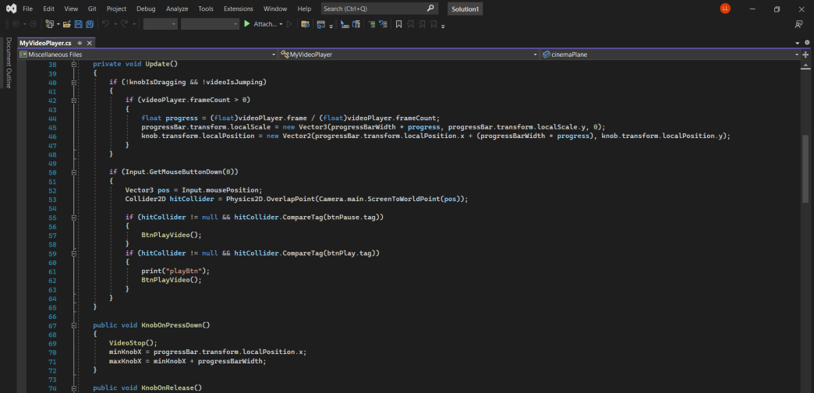Figure 16 shows the interactive system created in Unity.

**Figure 17:** Coding in Unity

Figure 17 shows the coding that is applied in Unity for the creation of the interactive system.

Results Interpretation and Analysis

To evaluate the interactive multimedia system, 10 Color-blind People and 10 Non- Color-blind people participated using targeted sampling.

To measure the effectiveness of the system for color-blind people the researchers utilized a questionnaire that was made by the researchers. The said evaluation module has been validated by an eye doctor as they are experts in the field.

To measure the positive experience of using the interactive multimedia system, the researchers utilized a usability evaluation questionnaire taken from a study conducted by Scepanovic, Vujicic, Matijevic, and Radunovic (2015). The researchers dispersed a google form containing the consent form, the link to the interactive system as well as the questionnaire. Respondents were required to play the interactive animated short film before answering the questionnaire.

To find out the results of the usability evaluation, the researchers used the Likert scale to measure the respondent’s attitudes toward the interactive system.

To find out the result of the evaluation module within the system the researchers solved the summative average of the scores of the viewers.

The Likert scale contained four responses assigned with a numerical value namely: Very Acceptable (4), Acceptable, (3), Moderately Acceptable (2), and Barely Acceptable (1); which would be used to measure the attitude under investigation.

To get the weighted mean (WM), the data gathered from the usability evaluation were analyzed using Microsoft Excel and interpreted using the 4-point Likert scale scoring range.

***Table 1.***

*4-point Likert scale scoring range*

|  |  |  |
| --- | --- | --- |
| **Value** | **Range** | **Interpretation** |
| 4  3  2  1 | 3.51 - 4.50  2.51 – 3.50  1.51 – 2.50  1.0 – 1.50 | Very Acceptable  Acceptable  Moderately Acceptable  Barely Acceptable |

System Evaluation Results

The usability evaluation was based on a study conducted by Scepanovic, Vujicic, Matijevic, and Radunovic (2015) about Game-Based Mobile Learning - Application Development and Evaluation. The usability evaluation was divided into four components namely: Interactive System Usability Components, Interactive System Mobility, Interactive Experience, and Learning Content Components.

Tables 2,3,4, and 5 presented tabulations of the usability evaluation of the Interactive System with the corresponding weighted mean (WM) and the descriptive interpretation (DI) of each indicator.

The usability evaluation results were measured using the Likert scale range interpretation.

***Table 2.***

*Results of the Interactive System Usability Components*

|  |  |  |
| --- | --- | --- |
| **Interactive System-Usability** | **Weighted Mean** | **Descriptive Interpretation** |
| 1. Audio-visual representation supports the system. | 3.5 | Acceptable |
| 2. The screen layout is easy to follow, well-organized, and visually pleasing. | 3.6 | Very Acceptable |
| 3. Navigation is consistent, logical, and minimalist. | 3.25 | Acceptable |
| 4. Control keys are consistent and follow standard conventions. | 3.4 | Acceptable |
| 5. System controls are convenient and flexible and the system is adapted to my screen size. | 3.4 | Acceptable |
| 6. The system gives feedback on the viewer’s actions. | 3.5 | Acceptable |
| 7. The system provides useful help. | 3.8 | Very Acceptable |

The indicators arranged according to their weighted mean and descriptive interpretation are as follows: IUC7 (WM=3.8, DI=Very Acceptable), IUC2 (WM= 3.6, DI=Very Acceptable), IUC6 (WM=3.5, DI=Acceptable), IUC1 (WM=3.5, DI=Acceptable), IUC4 (WM= 3.4, DI= Acceptable), IUC5 (WM=3.4, DI= Acceptable), and IUC3 (WM= 3.25, DI=Acceptable).

This indicates that the Usability of the Interactive System is Acceptable to the viewers.

***Table 3.***

*Results of the Mobility Components*

|  |  |  |
| --- | --- | --- |
| **Interactive System-Usability** | **Weighted Mean** | **Descriptive Interpretation** |
| 1. The system and play sessions can be started quickly. | 3.6 | Very Acceptable |
| 2. The system accommodates the surrounding. | 3.7 | Very Acceptable |
| 3. Interruptions are handled reasonably. | 3.65 | Very Acceptable |

The indicators arranged according to their weighted mean and descriptive interpretation are as follows: ISM2(WM=3.7, DI=Very Acceptable), ISM3 (WM= 3.65, DI-Very Acceptable), and ISM1 (WM= 3.6, DI= Very Acceptable).

This indicates that the Interactive System’s Mobility is Very Acceptable to the viewers. The system accommodates the surrounding of the gadget upon use.

***Table 4.***

*Results of Interactive Experience*

|  |  |  |
| --- | --- | --- |
| **Interactive Experience** | **Weighted Mean** | **Descriptive Interpretation** |
| 1. The interactive system provides clear goals. | 3.5 | Acceptable |
| 2. The viewer sees the progress in the system and can compare it with others. | 3.65 | Very Acceptable |
| 3. The viewer is in control of his/her pace in the system. | 3.65 | Very Acceptable |
| 4. The first-time experience is encouraging. | 3.55 | Very Acceptable |
| 5. There are no repetitive or boring tasks. | 3.4 | Acceptable |

The indicators arranged according to their weighted mean and descriptive interpretation are as follows: ISC2 (WM= 3.65, DI= Very Acceptable), ISC3 (WM= 3.65, DI= Very Acceptable), ISC4(WM= 3.55, DI= Very Acceptable), ISC1 (WM= 3.5, DI= Acceptable), and ISC5 (WM= 3.4, DI= Acceptable).

This indicates that the Interactive Experience is Very Acceptable to the viewers. The viewer is in control of his/her pace in the interactive system and the viewer can also see the progress and can compare it with others.

***Table 5.***

*Results of Learning Content Components*

|  |  |  |
| --- | --- | --- |
| **Learning Content Components** | **Weighted Mean** | **Descriptive Interpretation** |
| 1. The interactive system provides learning content. | 3.65 | Acceptable |
| 2. The content can be learned easily. | 3.75 | Very Acceptable |
| 3. The learning objective from the interactive system is achievable. | 3.5 | Very Acceptable |
| 4. The content is understandable. | 3.55 | Very Acceptable |

The indicators arranged according to their weighted mean and descriptive interpretation are as follows: LCC2 (WM= 3.75, DI= Very Acceptable), LCC1 (WM= 3.65, DI= Very Acceptable), LCC4 (WM= 3.55, DI= Very Acceptable), and LCC3 (WM= 3.55, DI= Very Acceptable).

This indicates that the Interactive System’s Learning Components are Very Acceptable to the viewers. This shows that the interactive system provides learning content, is achievable and the content is understandable.

***Table 6.***

*Results of the Components*

|  |  |  |
| --- | --- | --- |
| **Components** | **Weighted Mean** | **Descriptive Interpretation** |
| Interactive System Usability Components | 3.5 | Acceptable |
| Interactive Experience | 3.65 | Very Acceptable |
| Interactive System Components | 3.55 | Very Acceptable |
| Learning Content Components | 3.6 | Very Acceptable |

As for the results of the components, all but one

component garnered a “Very Acceptable” interpretation

with Interactive System Mobility having the highest weighted mean of 3.65, Learning Components with a score of 3.6, and Interactive Experience with a score of 3.55. While the Interactive Usability Components got the lowest score of 3.5.

This indicates that the Interactive System can promote learning through an interactive experience and create a helpful alternative for color-blind people who wants to watch movies but is unable to because he/she is unable to discern colors.

For the In-game Evaluation Module. The researchers gathered the scores of the viewers and got the summative average of all questions’ scores. There is a total of 20 respondents, 10 Color-blind people, and 10 Non-Color-blind people.

***Table 7.***

*Indicates number (%) with Yes or No answers.*

|  |  |  |
| --- | --- | --- |
| **Indicators** | **No. of Respondents responding Yes (%)** | **No. of Respondents responding No (%)** |
| 1. Are you able to tell the film’s colors apart? | 20 (100%) | 0 (0%) |
| 2. Were you able to identify the film’s key objects based on their color? | 19 (95%) | 1 (5%) |
| 3. Based on the color, were you able to determine the mood of particular movie scenes? | 19 (95%) | 1 (5%) |
| 4. Based on the color, were you able to comprehend the film’s plot? | 20 (100%) | 0 (0%) |
| 5. Did you find the movie’s colors to be harsh on the eyes? | 2 (10%) | 18 (90%) |
| 6. Do the colors of the movie’s characters strike you as being murky? | 0 (0%) | 20 (100%) |
| 7. Is the movie’s interactive system useful to you? | 20 (100%) | 0 (0%) |
| 8. Were you able to identify the causes of Color Blindness? | 19 (95%) | 1 (5%) |
| 9. Were you able to identify the type of Color Blindness? | 20 (100%) | 0 (0%) |
| 10. Do you find the movie to be color-blind-friendly? | 20 (100%) | 0 (0%) |
| 11. Is there a difference between the Non-Color-blind film and the Color-blind Film? | 20 (100%) | 0 (0%) |

According to the results above 100% of the viewers were able to tell the film’s colors apart, 95% of the viewers were able to identify the film’s key objects based on their color, 95% of the viewers were able to determine the mood of particular scenes base on the color, 100% were able to comprehend the plot of the film based on the color, 10% were able to find the movie’s color’s to be harsh on the eyes, 0% thinks the colors of the movie characters to be murky, 100% find the interactive system of the movie to be useful, 95% were able to identify the causes of color-blindness, 100% were able to identify the type of color-blindness, 100% find the movie to be color-blind-friendly, and 100% said that there is a difference between the non-color-blind film and color-blind film.

5% were not able to identify the film’s key objects based on the color, 5% were not able to determine the mood of particular scenes based on the color, 90% did not find the film’s colors to be harsh on the eyes, 100% did not find the colors of the characters to be murky, and 5% were not able to identify the causes of color-blindness. This indicates that the majority of the respondents think that the film is color-blind-friendly for all types of color-blindness and the majority think that there is a difference between the non-color-blind film and the color-blind film.

Cherry (2013) asserts that color is a potent communication tool that may be utilized to communicate action, alter emotion, and even physiological responses. Since color-blind people cannot discern colors using colors as a communication tool might be proven to be difficult for them. The usual emotions felt by non-color-blind people might not be felt by the ones who are color-blind, as the colors the color-blind people see are almost the same. The system will make a very good alternative for the color-blind in watching movies while applying the features of color-blind accessibility. It is crucial to highlight, however, that there is still much that can be improved in the film's animation to make the experience more meaningful and pleasant.

CHAPTER 5 SUMMARY, CONCLUSIONS, AND RECOMMENDATIONS

Summary of the Proposed Study Design and Implementation

Color may make someone feel a specific way based on whether or not somebody enjoys that particular color. It is an extremely effective communication tool that may be used to communicate action, alter mood, and even influence physiological reactions. Having identified the problems of color-blind people when it comes to movies, as not being understandable enough because of the lack of ability to perceive colors fully; the system was built in response to these problems. This issue caused the researchers to create a 2D interactive animated short film that could potentially assist color-blind people in understanding the colors of any film.

Animation is commonly used for entertainment and learning; however, researchers are studying its potential when it comes to helping color-blind people to understand the colors of any film in the future. They also have concluded that incorporating an animated movie inside an interactive system with the feature of choosing the kind of color-blindness the viewer has, would be beneficial to color-blind people. Since most games now have color-blind accessibility, why not include it in movies as well? Having to match the hue of the film to the sort of color-blindness the viewer has would be advantageous not only to the viewer but also to future filmmakers who may wish to integrate this feature in future films. Not only that but, this would be easy to access as the majority of people use gadgets and spend a huge amount of time using them. A poll was done with 20 participants, ten of whom were color-blind and ten of whom were not. Participants were invited to complete a questionnaire on their feelings about the interactive system. Animation is arduous and time-consuming, and it requires a lot of people to work on it. It is recommended to divide the work among the members equally in order to assure that the output will be passed on time whilst maintaining its quality. For the Color-blind viewers, the researchers recommend promoting or prioritizing interactive color-blind friendly systems or visuals. As it will be helpful for them and future generations if they help those interactive systems to improve more.

Summary of Findings

A survey adapting the 4-point Likert scale along with the Likert scale scoring was used in the conduct of the study. 20 participants, ten of whom were color-blind and ten of whom were non-color-blind, were asked to play the interactive system and watch the movie within. They were then asked to answer a google questionnaire form. The contents of the form were the usability of the interactive system, its mobility, the experience, and the educational content. The results showed that some of the respondents found the interactive system usability to be convenient and the game adjusts to the screen size of their PC platforms.

For mobility components, the interactive sessions were regarded to start quickly and accommodated the surroundings.

In the interactive experience, the viewer responded that he or she is in charge of his or her speed in the interactive system, and the viewer can also observe and compare his or her progress with others.

A majority of the respondents answered in the learning content component that they were able to learn something new after trying the interactive system.

Overall, the interactive system delivered great

learning and gaming experience for the audience and may be employed as an effective component in future films.

Conclusions

Relative to the findings the following conclusions were drawn:

Color-blind persons have had to make several adaptations throughout the years. Adjustments have been made to help people with this impairment manage in everyday life, gaming, and even the workplace. Understanding the colors that are important in everyday life has proven challenging for many with this condition. People who are color-blind find it difficult to enjoy the amusement provided by movies. As a result, there is a need for reform in the entertainment business that will allow persons with color-blindness to enjoy watching films without having to wonder what color the character's attire is or what time of day it is on that scene.

In this study, animation and interactive systems were investigated in terms of their efficacy for color-blind persons. After seeing the animation, respondents were given a download of the software as well as a questionnaire form to fill out. The learning and engaging experience, as well as the system's performance among color-blind persons, received generally excellent responses. Interactive System Mobility garnered the highest weighted mean of 3.6, Learning Components with a score of 3.6, and Interactive Experience with a score of 3.55. While the Interactive Usability Components got the lowest score of 3.5.

In the In-game evaluation module, results showed that 100% of the viewers were able to tell the film’s colors apart, 95% of the viewers were able to identify the film’s key objects based on their color, 95% of the viewers were able to determine the mood of particular scenes base on the color, 100% were able to comprehend the plot of the film based on the color, 10% were able to find the movie’s color’s to be harsh on the eyes, 0% thinks the colors of the movie characters to be murky, 100% find the interactive system of the movie to be useful, 95% were able to identify the causes of color-blindness, 100% were able to identify the type of color-blindness, 100% find the movie to be color-blind-friendly, and 100% said that there is a difference between the non-color-blind film and color-blind film.

5% were not able to identify the film’s key objects based on the color, 5% were not able to determine the mood of particular scenes based on the color, 90% did not find the film’s colors to be harsh on the eyes, 100% did not find the colors of the characters to be murky, and 5% were not able to identify the causes of color-blindness. This indicates that the majority of the respondents think that the film is color-blind-friendly for all types of color-blindness and the majority think that there is a difference between the non-color-blind film and the color-blind film.

Recommendations

Following the completion of this study, it was discovered that the Interactive System can promote learning and be used as a tool to assist color-blind individuals in understanding and watching films without the usage of enchroma glasses. However, it is advised that future researchers divide the labor evenly among the members in order to ensure that the result is delivered on time while retaining its quality. Future researchers should test this approach on a larger number of people, particularly those who are color-blind. It is also advised that this system include a server to automatically record the scores and responses that the responders or viewers have entered. For the Color-blind viewers, the researchers recommend promoting or prioritizing interactive color-blind friendly systems or visuals. As it will be helpful for them and future generations if they help those interactive systems to improve more. It is also suggested that there will be a feature within the interactive system where the viewer can know on what is the original color of the film as they hover over the screen. Is it also highly recommended that future researchers upgrade this system so that it will also be helpful in the field of medicine and science.

References

Blind (2014). *“Ink by Coldplay”*. Directed by Matthew Encina. Retrieved from <https://blind.com/work/project/coldplay-ink/>

<https://video.eko.com/v/coldplay-ink-> Link for the video

Cleveland Clinic. (n.d.). Color Blindness: Types, Causes & Treatments. Retrieved from [https://my.clevelandclinic.org/health/diseases/11604-color-blindness](https://my.clevelandclinic.org/health/diseases/11604-color-blindness%20)

Color Vision Deficiency. AOA.org (n.d.). Retrieved from <https://www.aoa.org/healthy-eyes/eye-and-vision-conditions/color-vision-deficiency?sso=y>

Colour Blind Awareness. *Types of Colour Blindness* (2022, April 1). Retrieved from [https://www.colourblindawareness.org/colour-blindness/types-of-colour-blindness/](https://www.colourblindawareness.org/colour-blindness/types-of-colour-blindness/%20)

Fang, Z., Cai, L., Juan, G., and Wang, G. 2021. *Interactive movie design based on the game engine technology.* In Proceedings of the 2020 4th International Conference on Electronic Information Technology and Computer Engineering (EITCE 2020). Association for Computing Machinery, New York, NY, USA, 1029–1033. Retrieved from <https://doi.org/10.1145/3443467.3443900>

Flynn S. (2020, November 21). *Colorblind-Friendly Gaming: How is the industry evolving?* App Trigger. Retrieved from https://apptrigger.com/2020/11/21/colorblind-friendly-gaming/

Fudge Animation (2016, October 19). *Interactive Animation.* Retrieved from <https://www.fudgeanimation.com/interactive-animation/>

Hadkins, H., & Lewis, S. (2011). *Interactive*. Cambridge University Press.

Hardin, B. (2016). *Colorblind Accessibility in Video Games- Is the Industry Heading to the Right Direction?* Retrieved from <https://www.gamersexperience.com/colorblind-accessibility-in-video-games-is-the-industry-heading-in-the-right-direction/>

Kirn, P. (2010). *In Animated Film Ishihara, an*

*Exploration of Color Blindness, All in Dots. A Film by Yoav Brill.* Retrieved from <https://cdm.link/2010/12/in-animated-film-ishihara-an-exploration-of-color-blindness-all-in-dots/>

https://vimeo.com/15888296 **- Link for the video**

Lutz, F. (2016, May 31). *How Color Blindness Affects your Entertainment.* Retrieved from <https://www.williammerrillgallery.com/how-color-blindness-affects-your-entertainment/>

Oducado, R.M. (2020). Survey Instrument Validation Rating Scale. [http://dx.doi.org/10.2139/ssrn.3789575](https://dx.doi.org/10.2139/ssrn.3789575)

PR Newswire (2016). *News Provided by Koenig Films, Inc. Sight: The Story of Vision- Documentary Film. Directed by Kris Koenig.* Retrieved from <https://www.prnewswire.com/news-releases/vision-documentary-first-film-ever-to-be-color-adapted-for-the-color-blind-300322645.html>

Sacks, O. W. (1997). *The Island of the Colorblind.* Vintage Books.

Schafer, C. (2021, October 18). *Color Blindness Accessibility.* Siteimprove. Retrieved from [https://www.siteimprove.com/blog/color-blindness-accessibility/#:~:text=In%20web%20design%2C%20color%20blindness,experience%20your%20website%20as%20intended](https://www.siteimprove.com/blog/color-blindness-accessibility/%23:~:text=In%20web%20design%2C%20color%20blindness,experience%20your%20website%20as%20intended%20)Scepanovic, S. (2015). GAME-BASED MOBILE LEARNING – APPLICATION DEVELOPMENT AND EVALUATION.

Stefyn, N. (2022, January 1). *What is 2D Animation? How to become a 2D Animator.* CG Spectrum. Retrieved from <https://www.cgspectrum.com/blog/what-is-2d-animation>

<https://vimeo.com/15888296> **- Link for the video**

WebMD Editorial Contributors(n.d.). *Color Blindness: How it happens and what causes it.* WebMD. Retrieved from <https://www.webmd.com/eye-health/color-blindness#:~:text=What%20Causes%20Color%20Blindness%3F,chemical%20damage%20to%20the%20eye>

Yu, D. (2015). *"See a Different World: Interactive Storytelling for Children to Raise Awareness of Color Blindness"*. Thesis. Rochester Institute of Technology. Accessed from <https://scholarworks.rit.edu/cgi/viewcontent.cgi?referer=&httpsredir=1&article=10085&context=theses>

Appendices

Appendix A

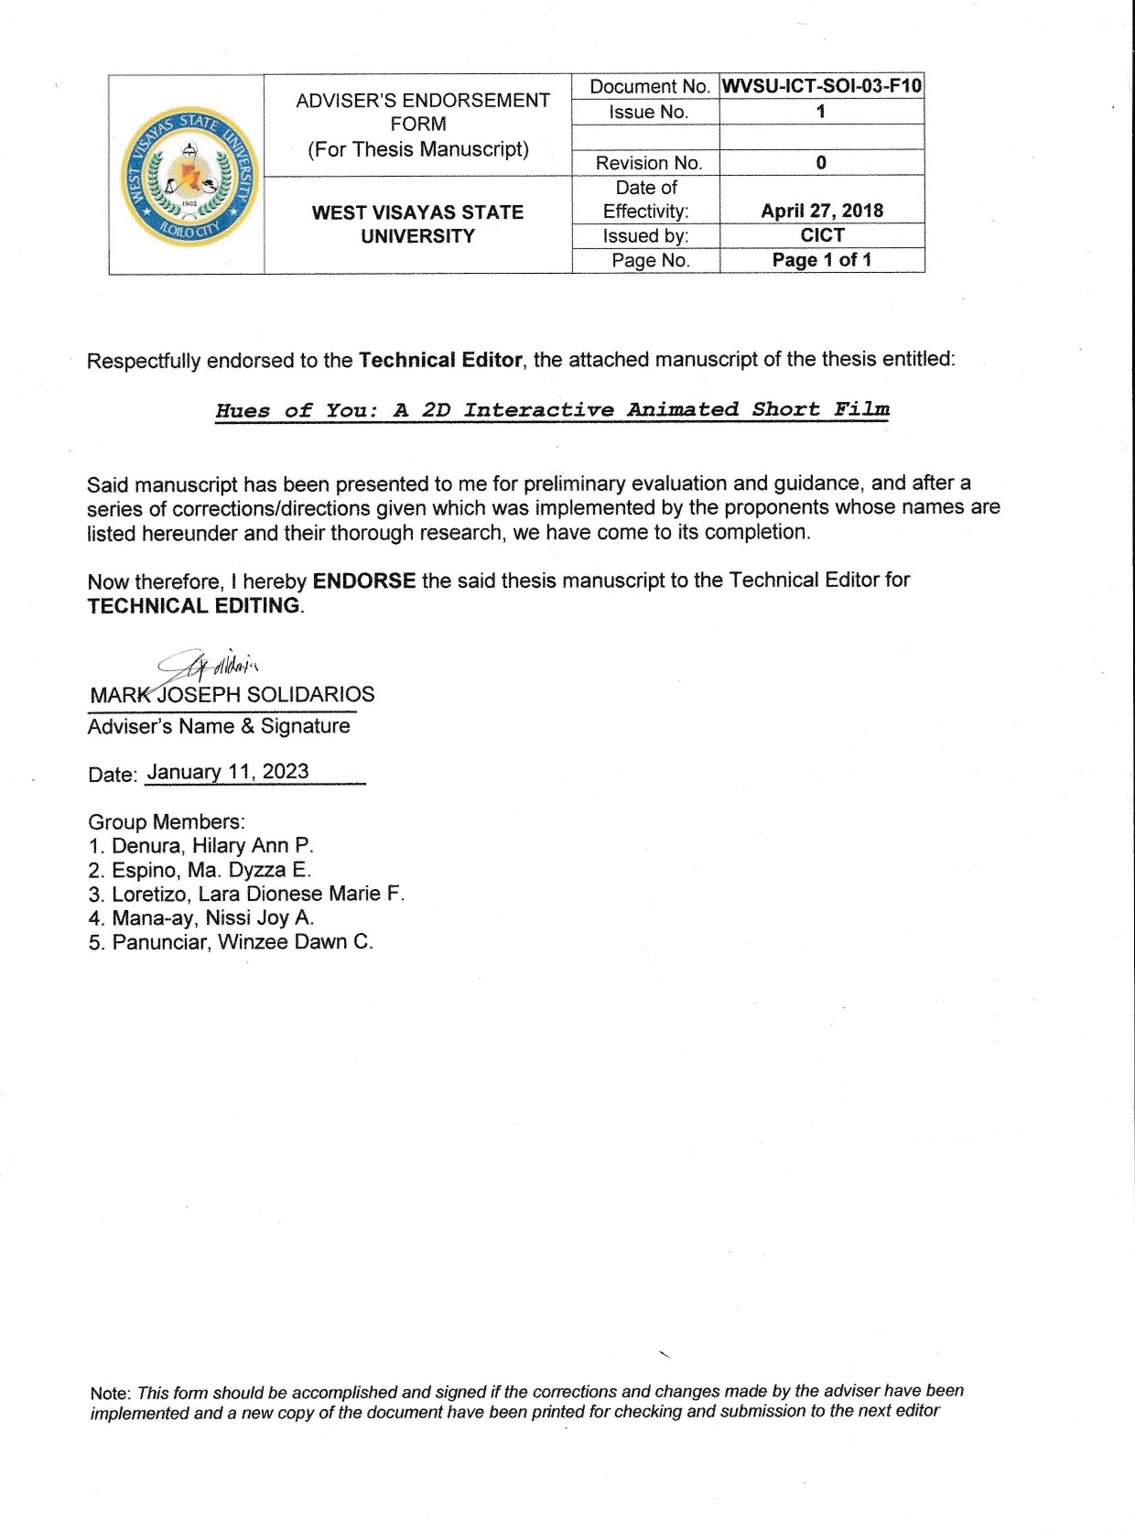Letter to the Adviser

Appendix B

Letter to the Technical Editor



Appendix C

Letter to the English Editor

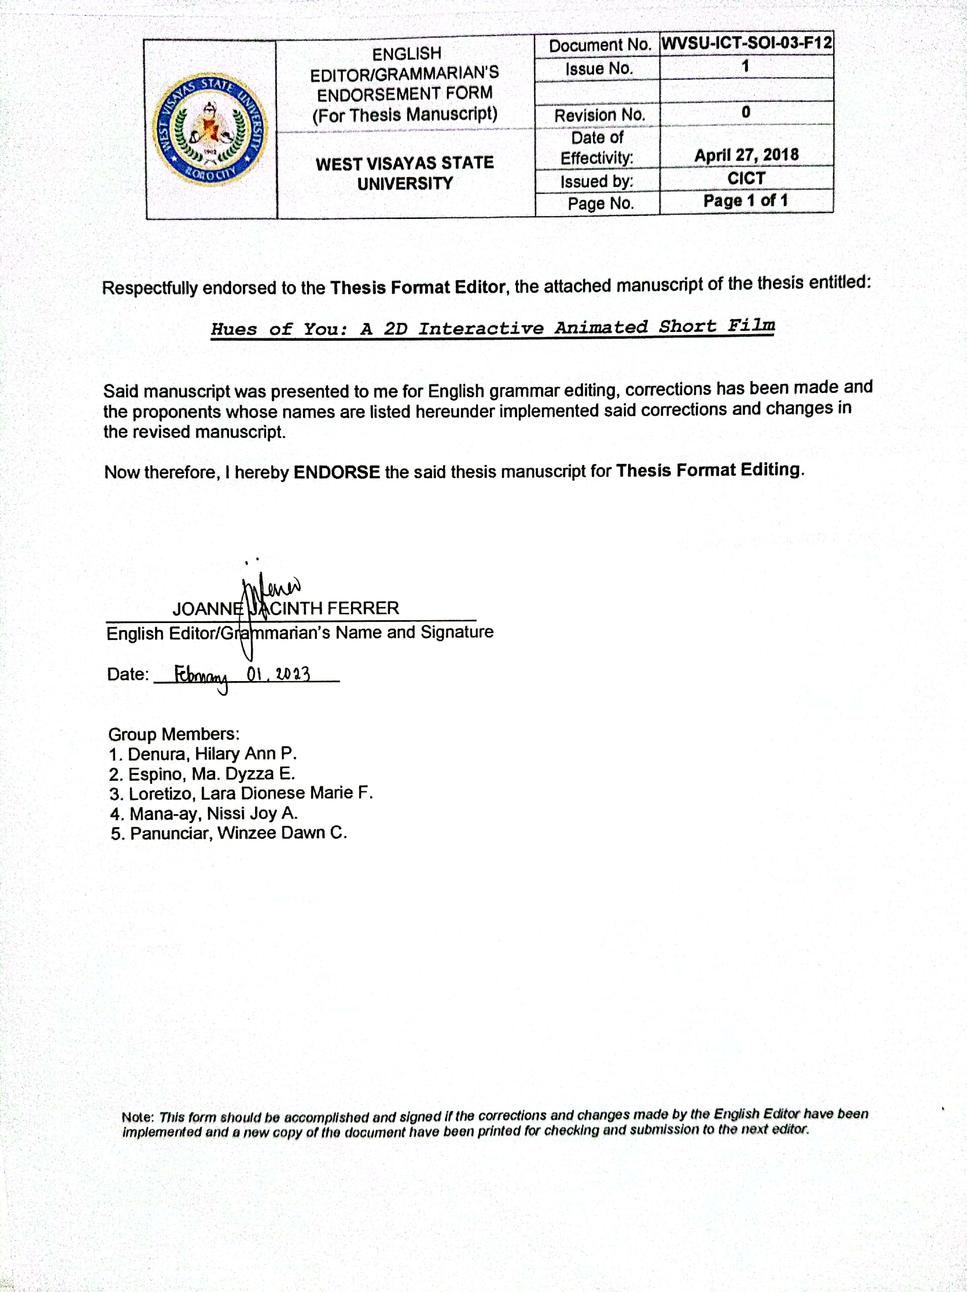

Appendix D

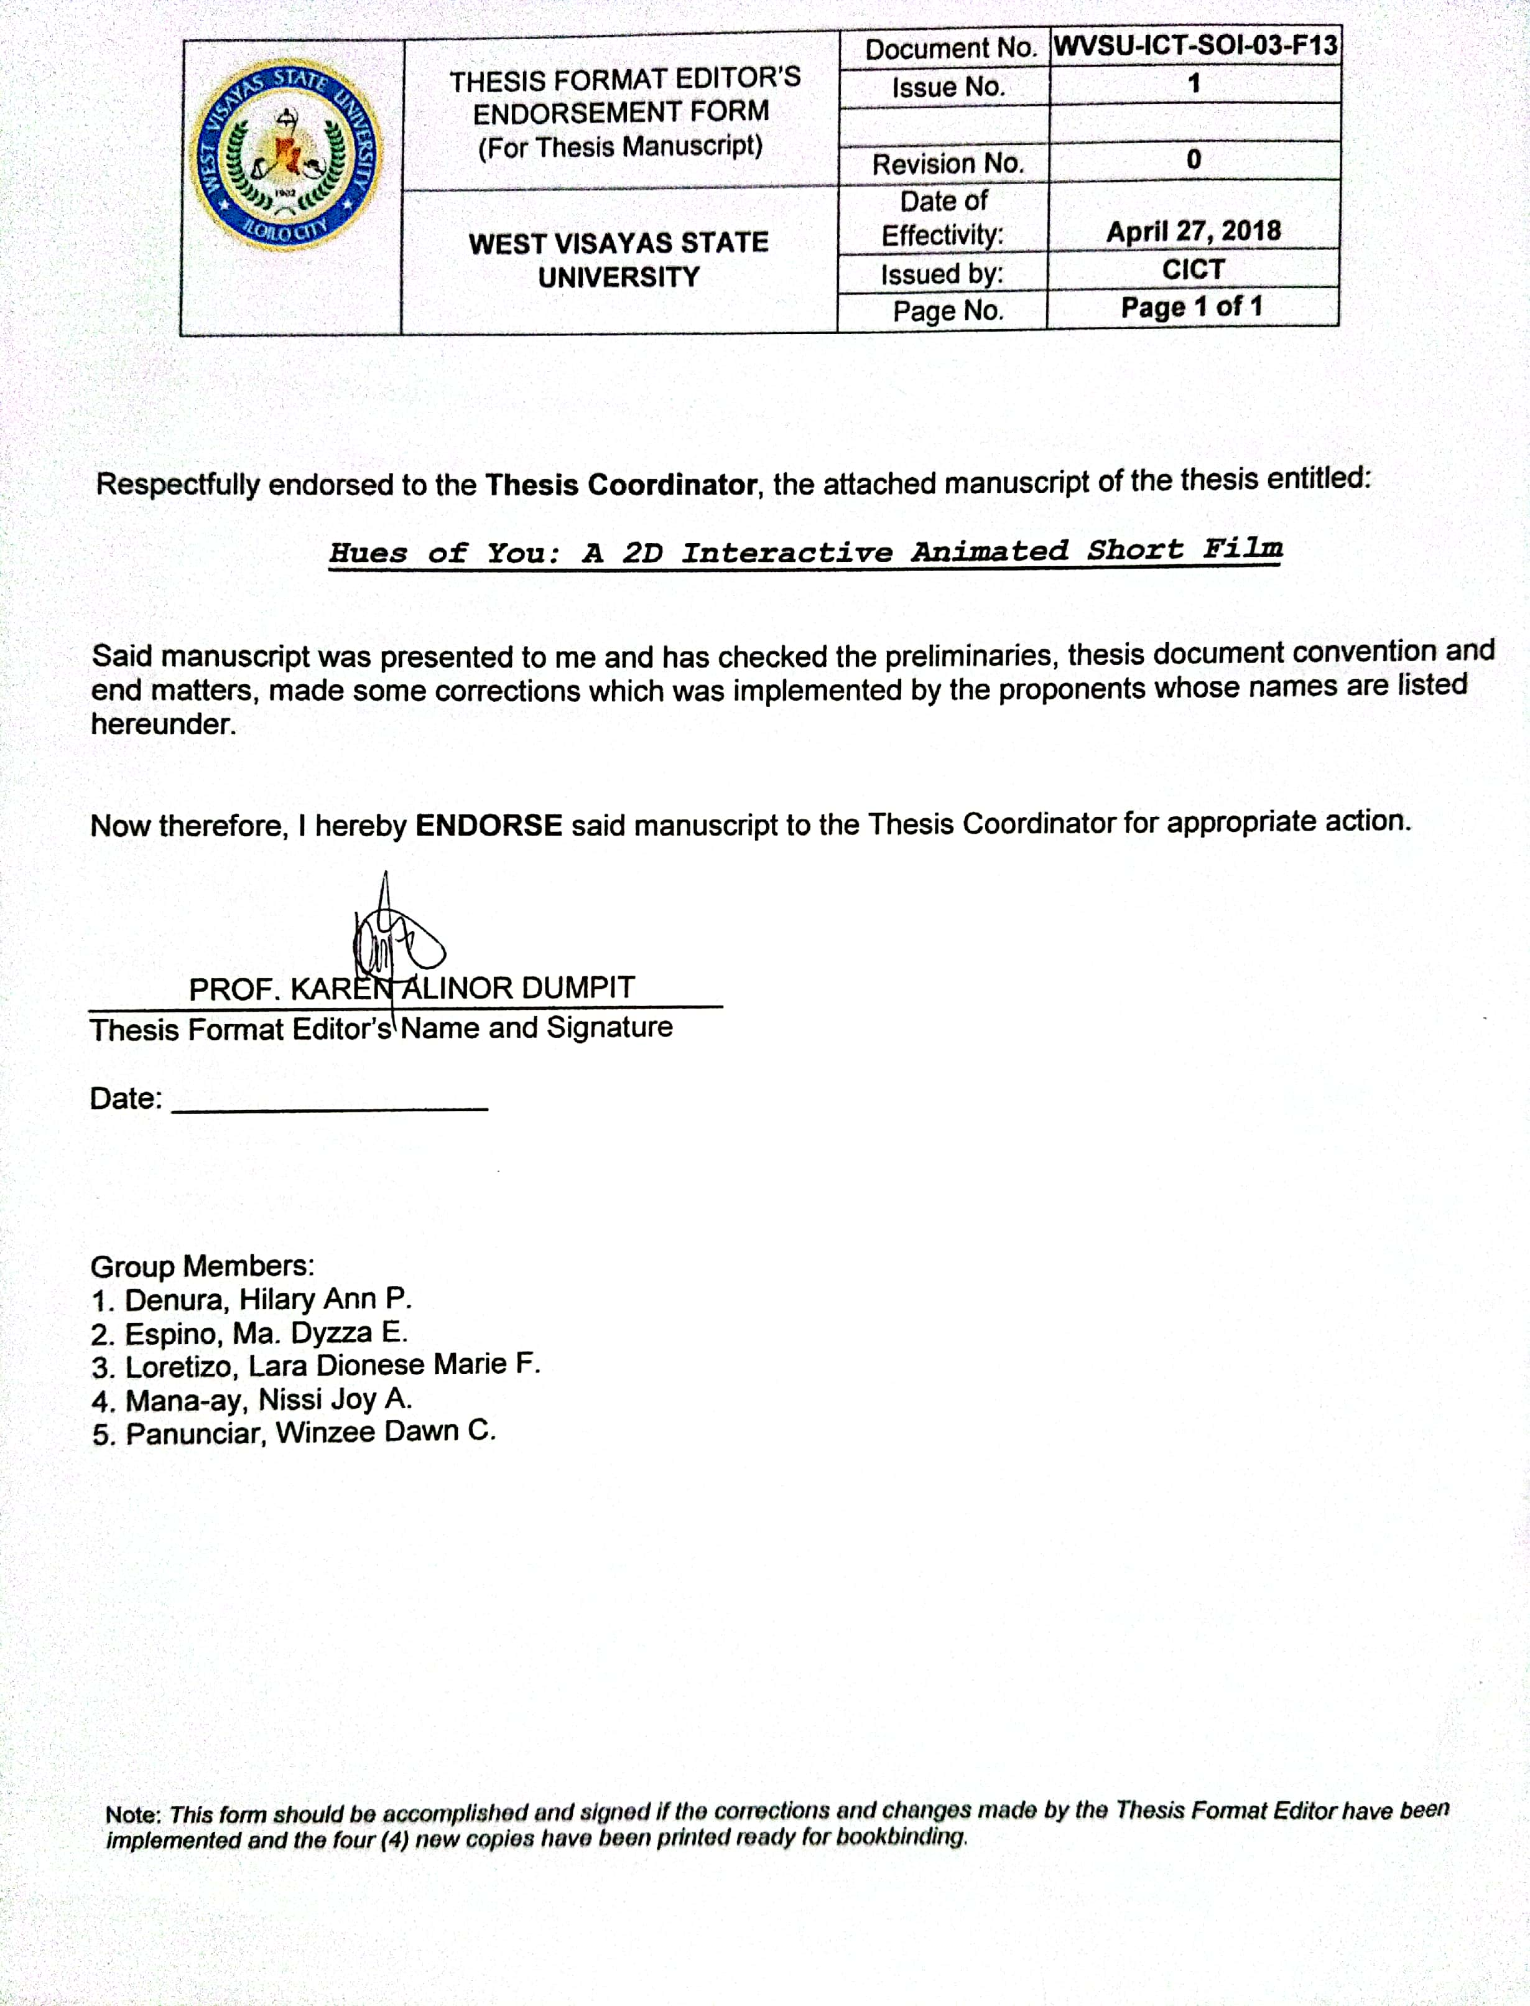Letter to the Thesis Format Editor

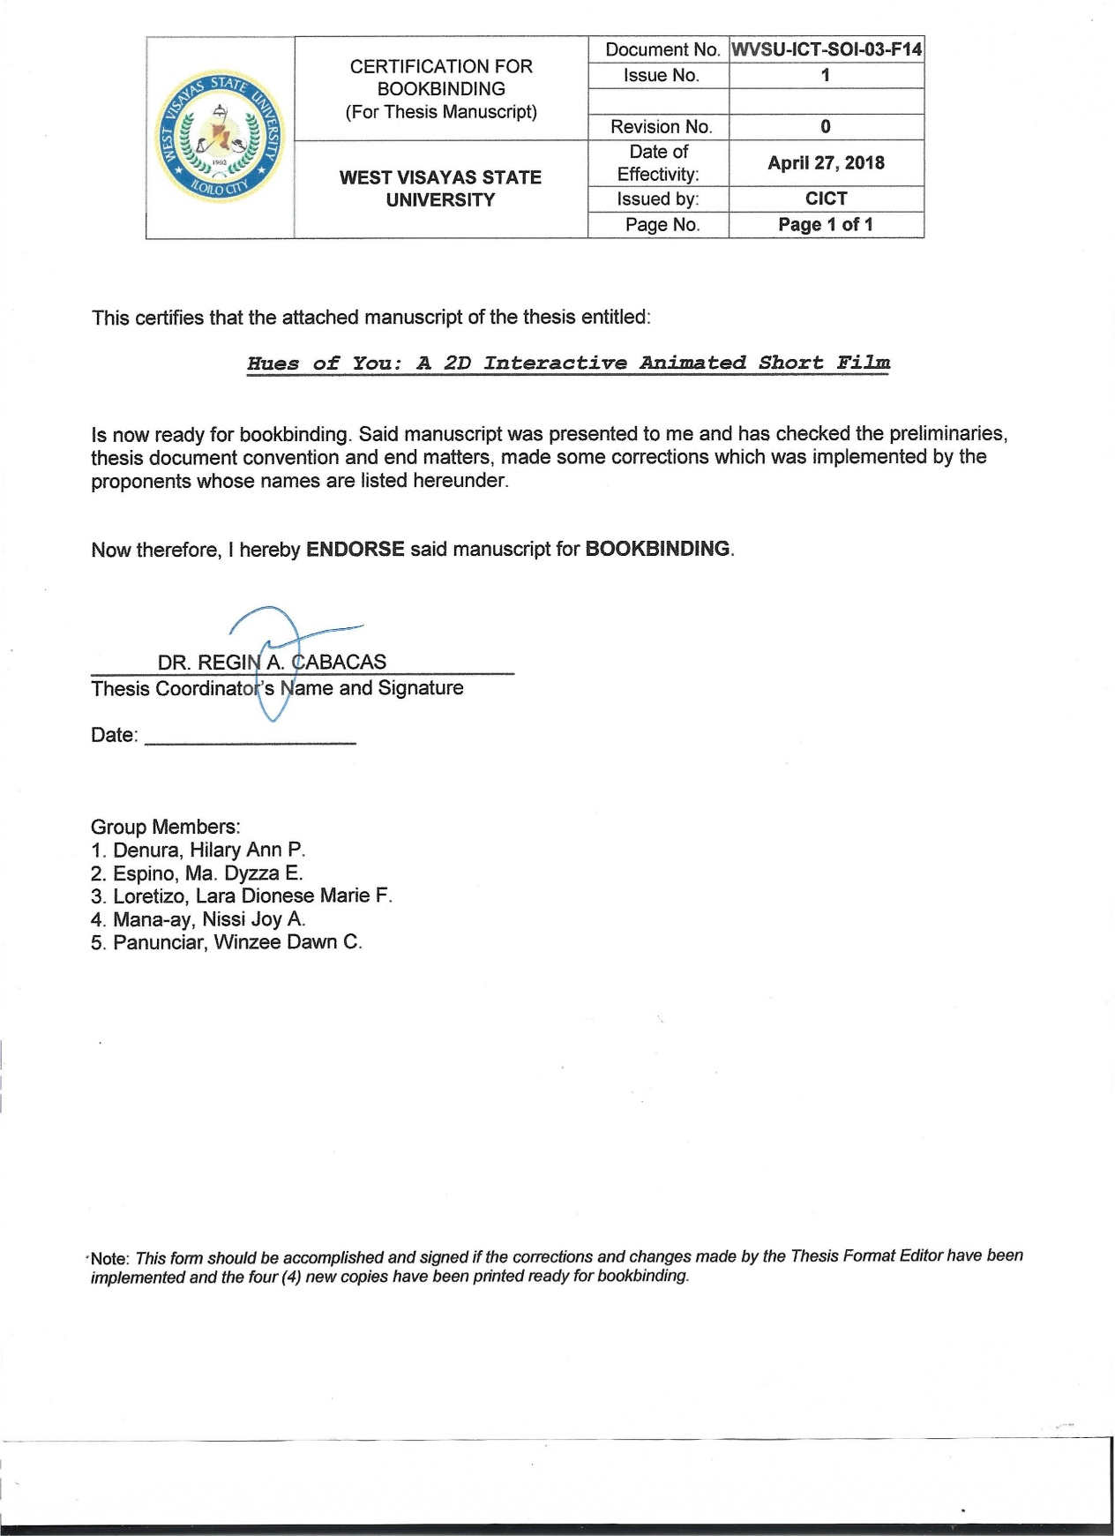Appendix E

Certification for Bookbinding

Appendix F

Letter of Permission for Interview

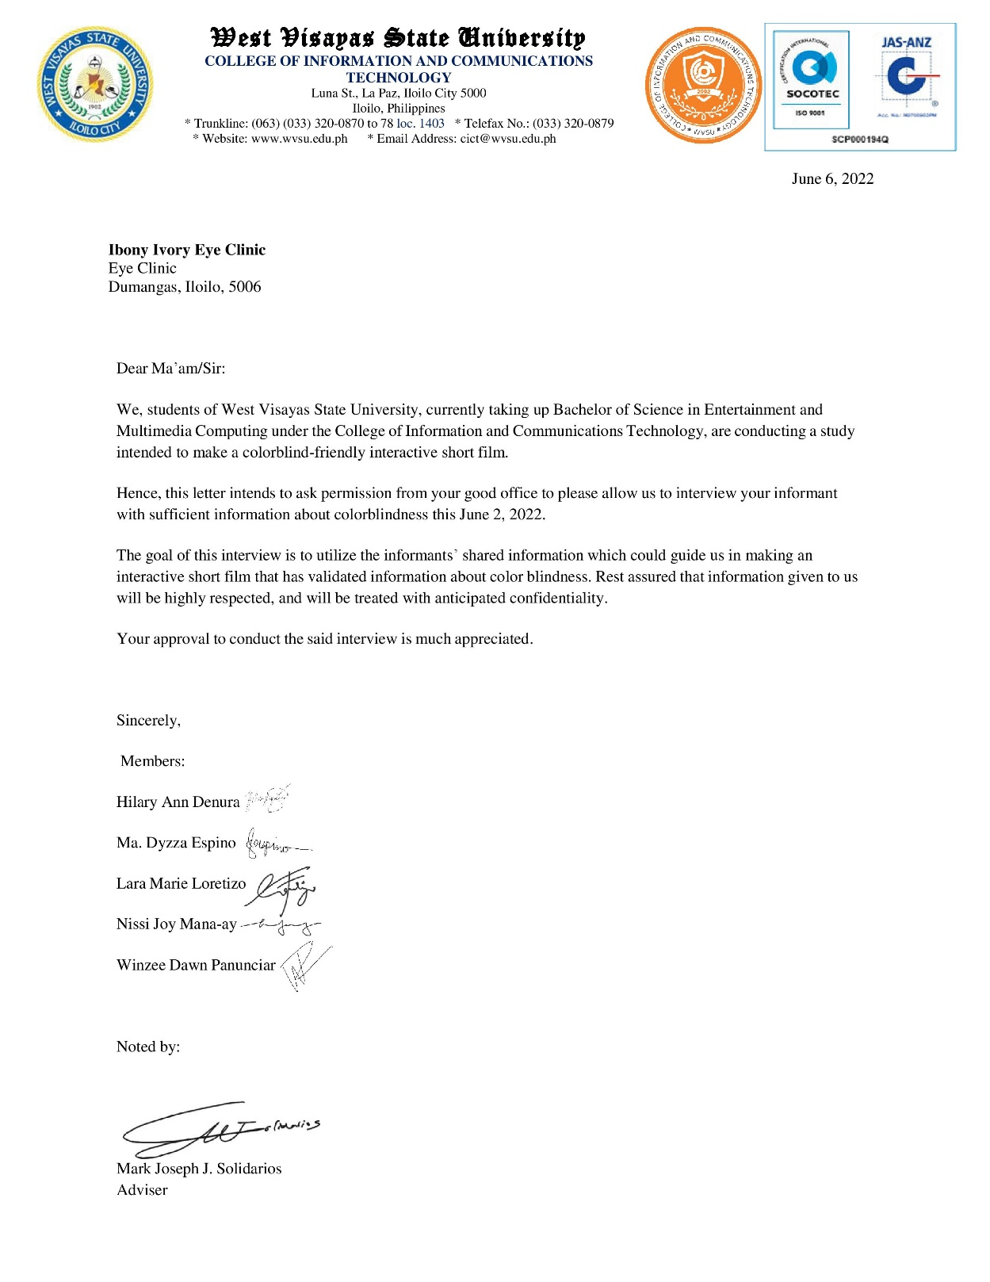

Appendix G

Letter of Validation

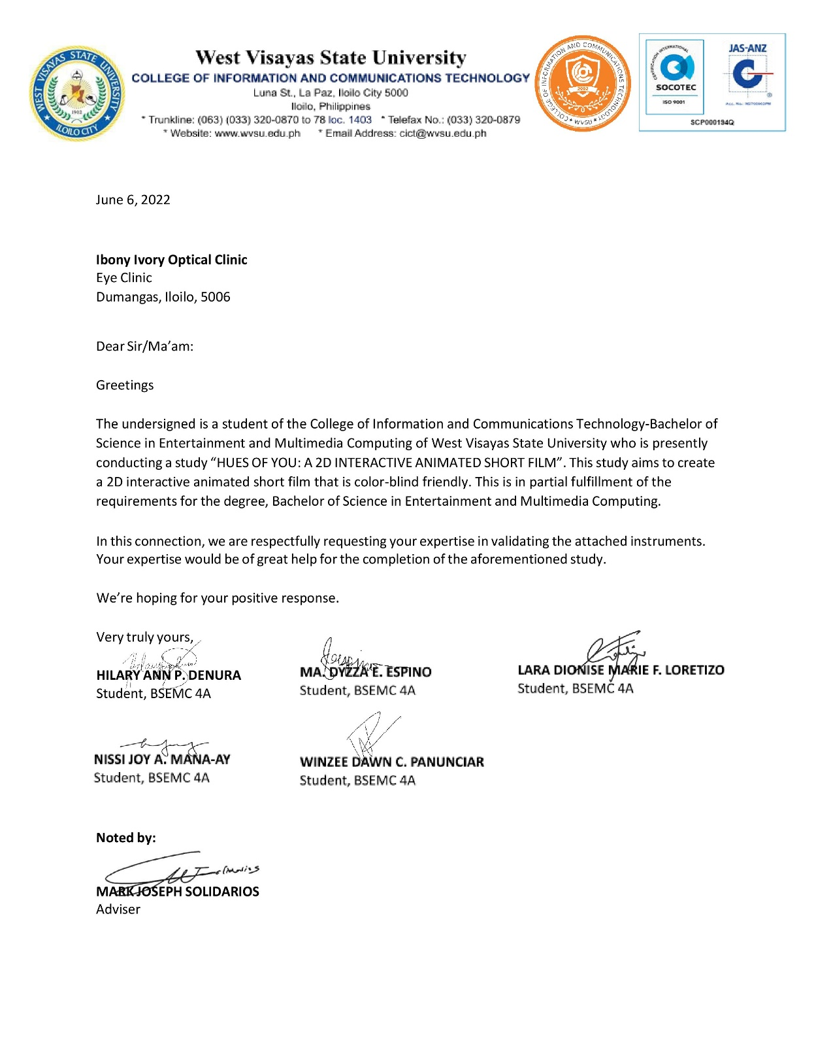

Appendix H

Letter of Permission for Interview 2

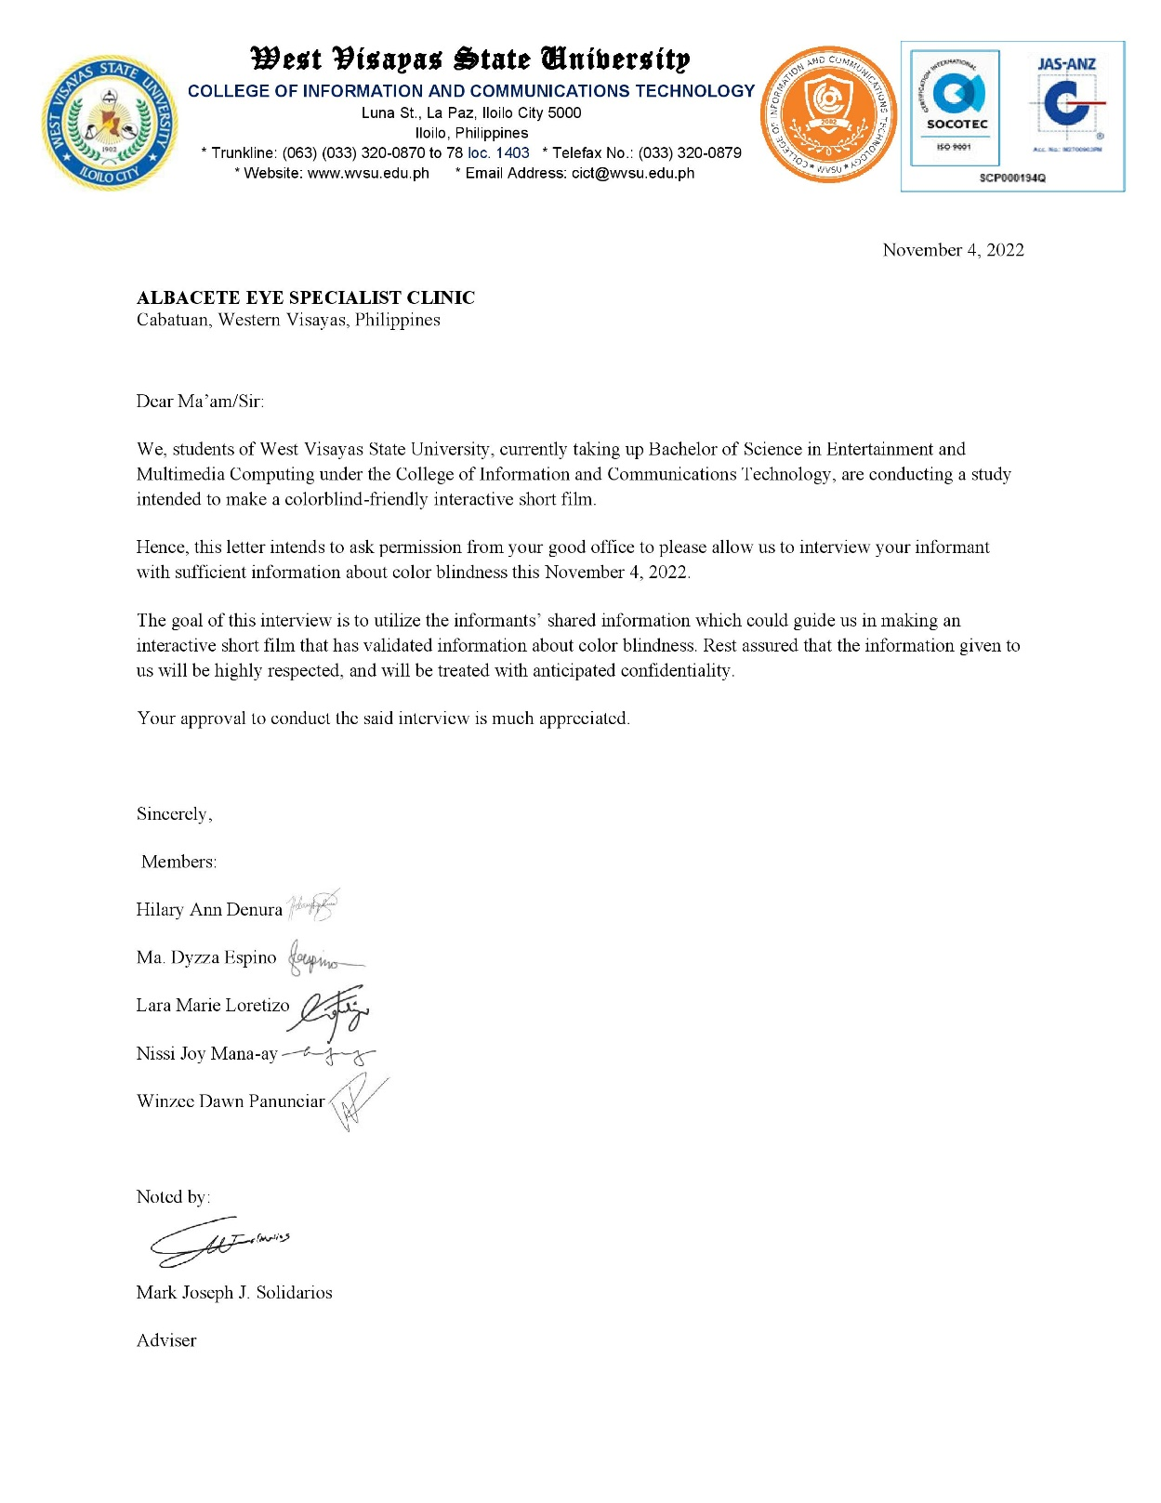

Appendix I

Letter of Validation 2

Appendix J

Production Cost Estimate

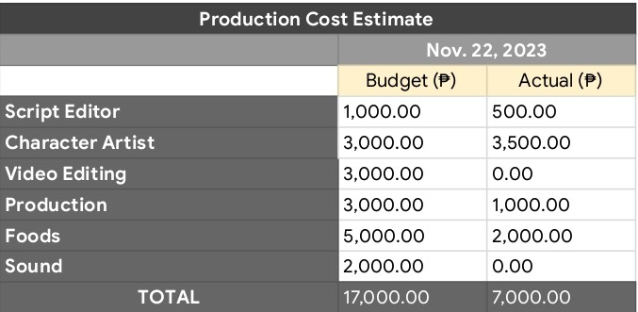

Appendix K

Activity Diagram



Appendix L

Sample Program Codes

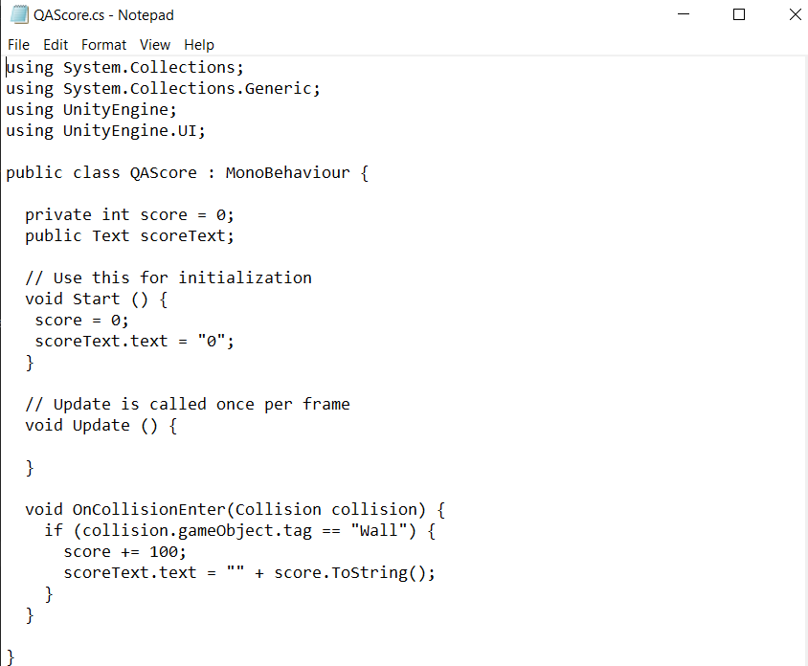

Appendix M

Viewer Evaluation Module Quesionnaire

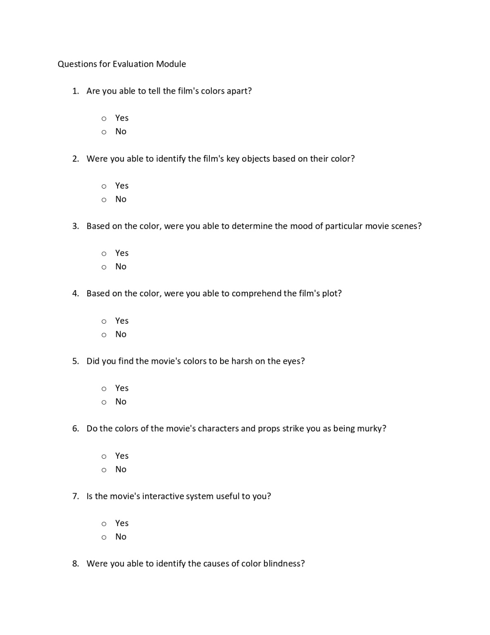

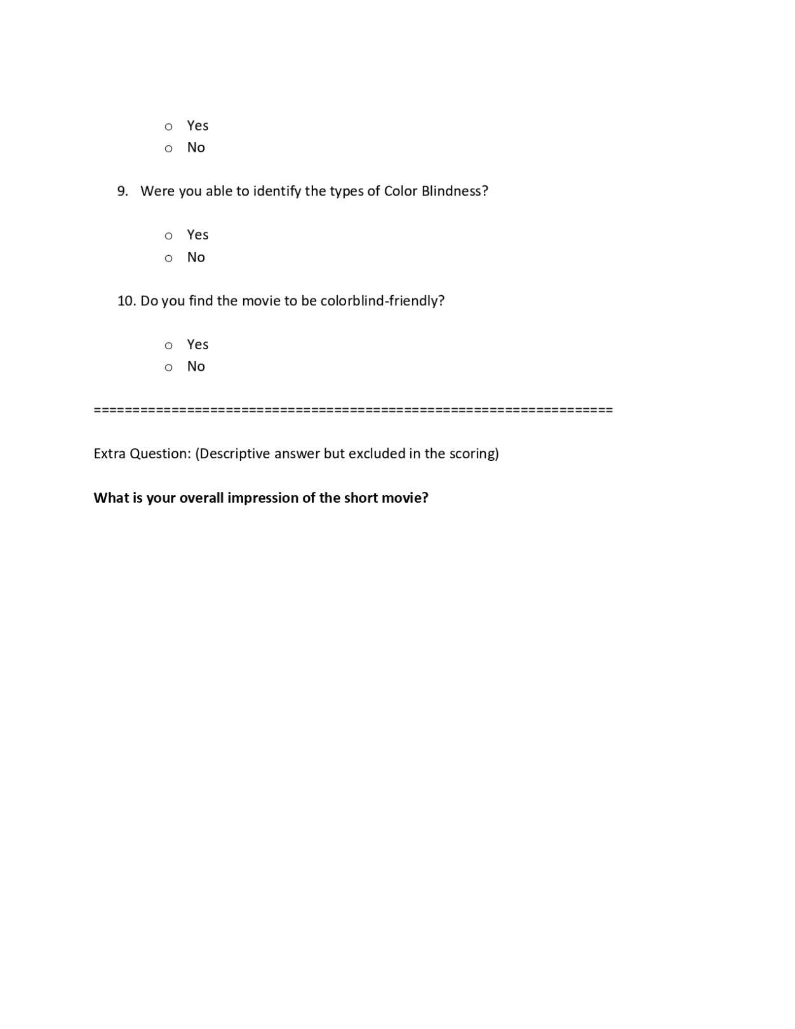

Appendix N

Interactive System Evaluation Questionnaire

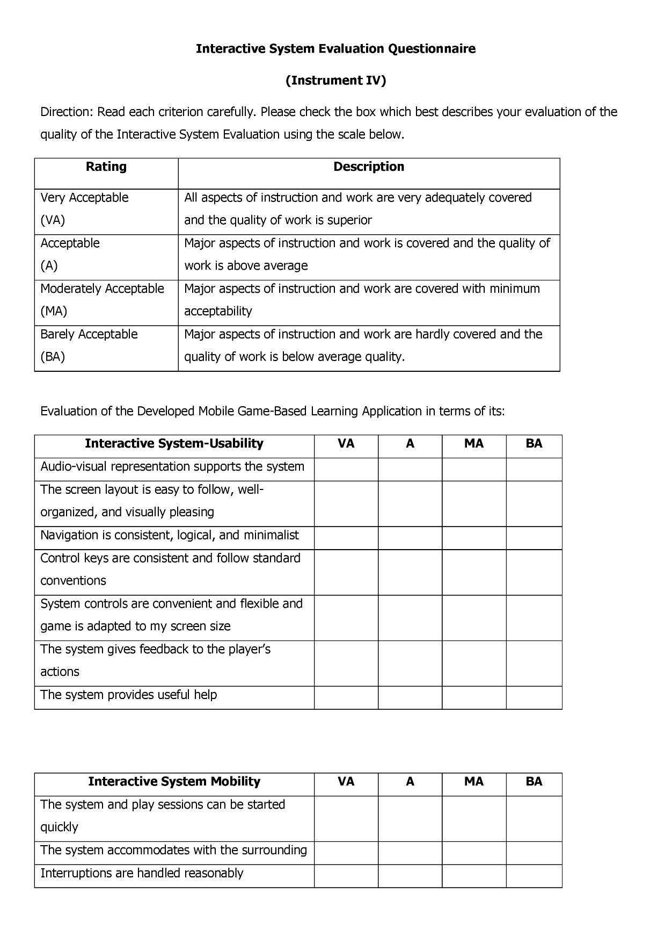

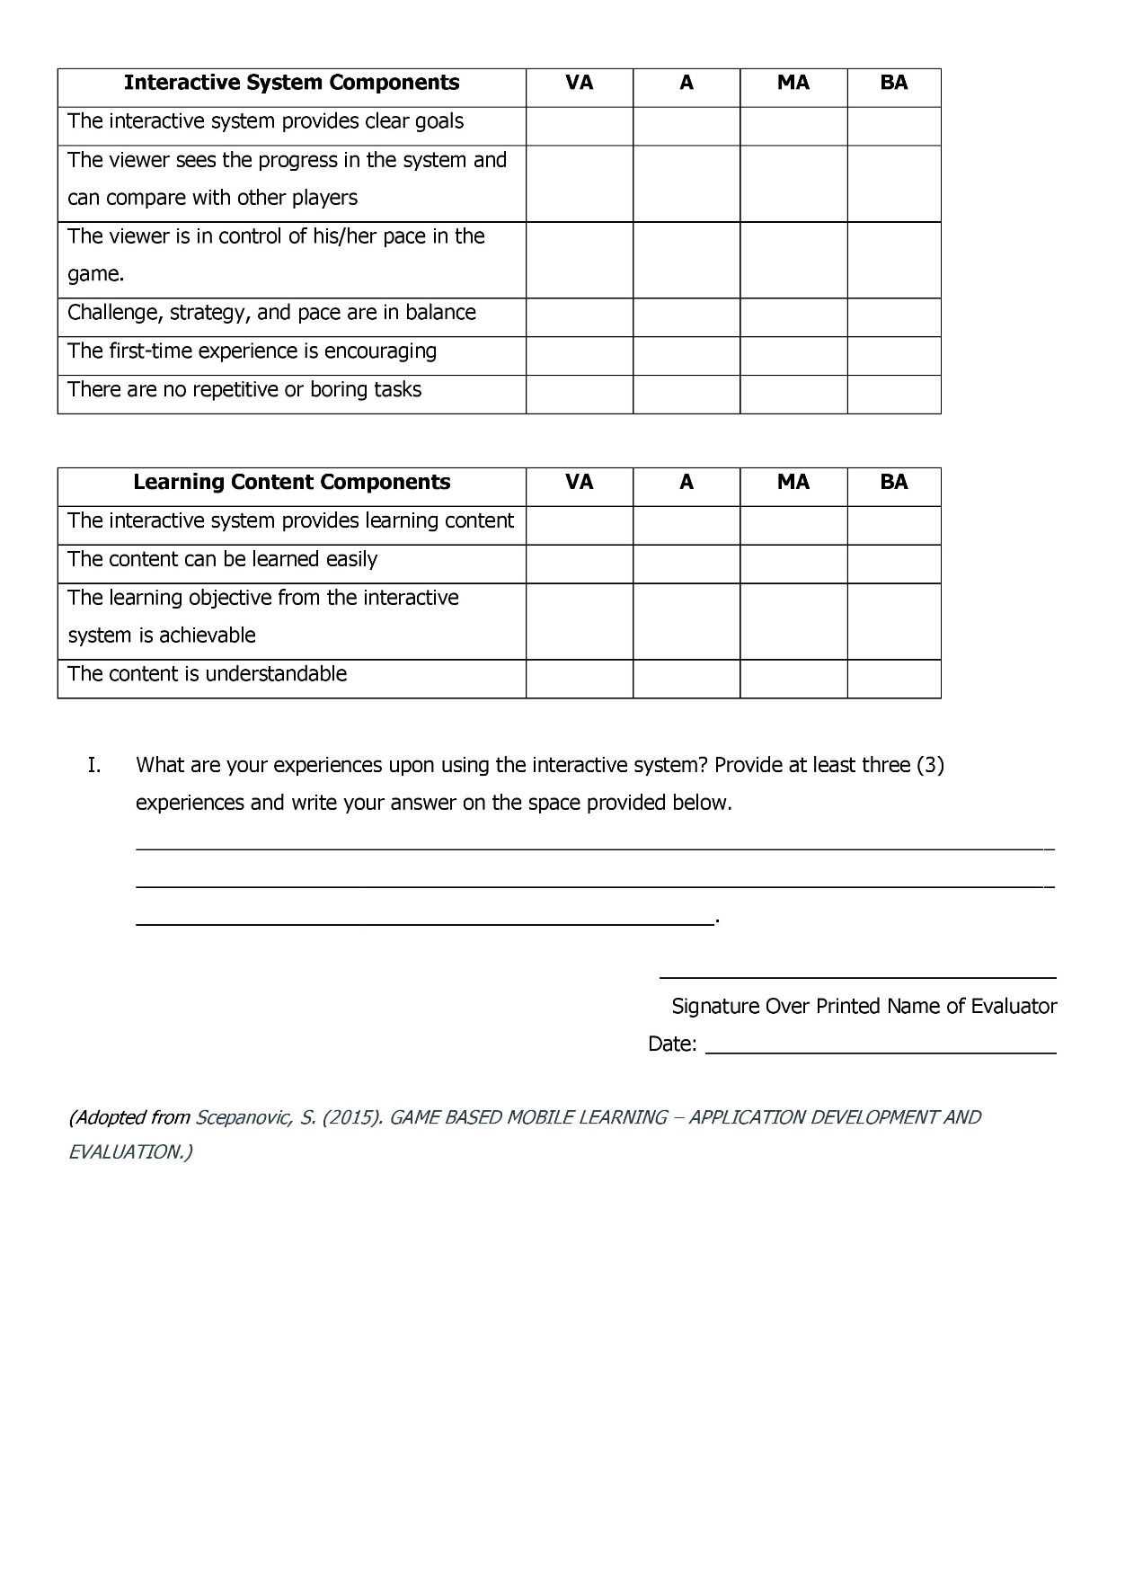

Appendix O

Survey Instrument Validation Scale

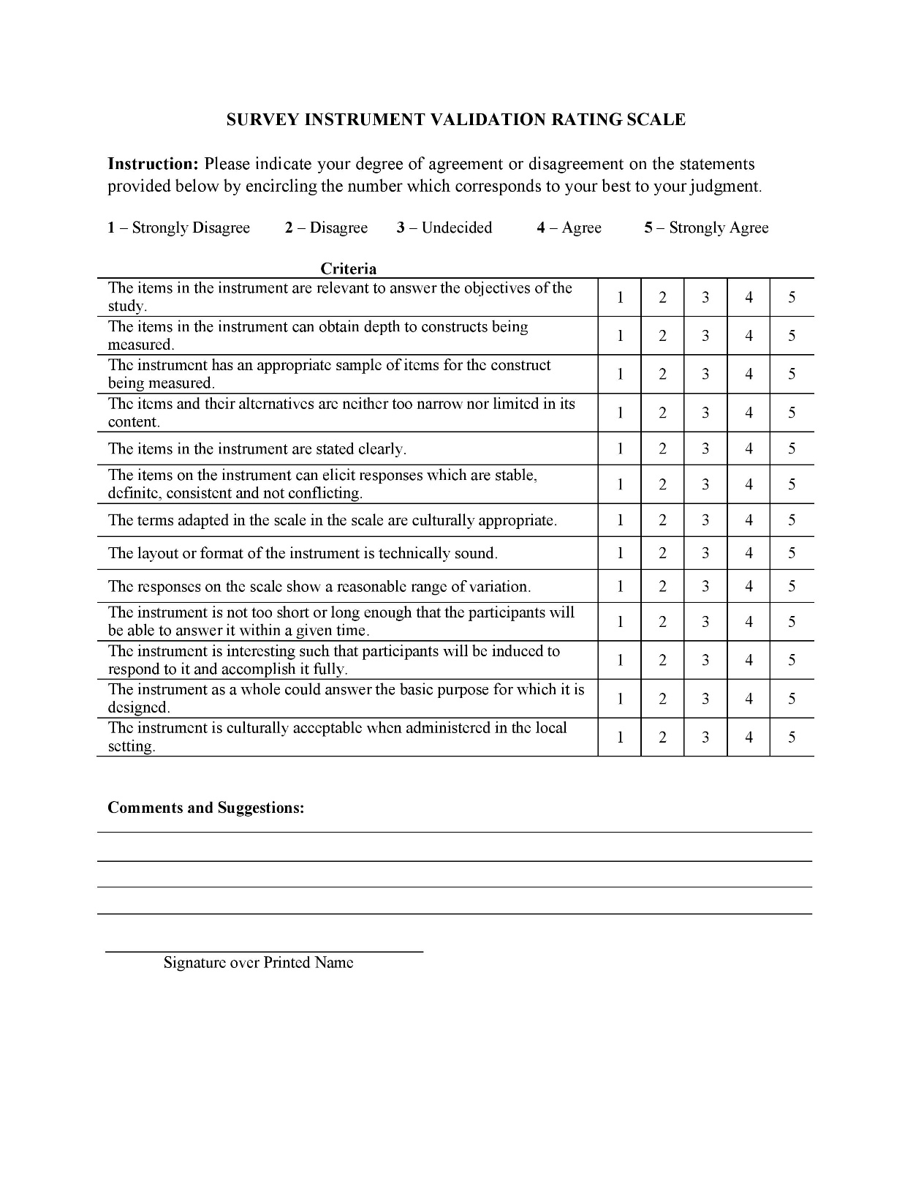

Appendix P

Documentation

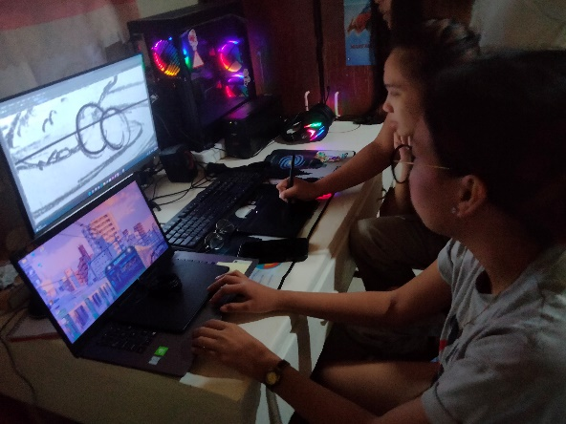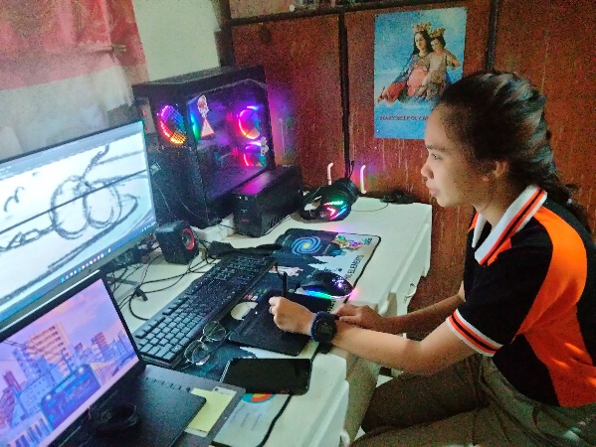

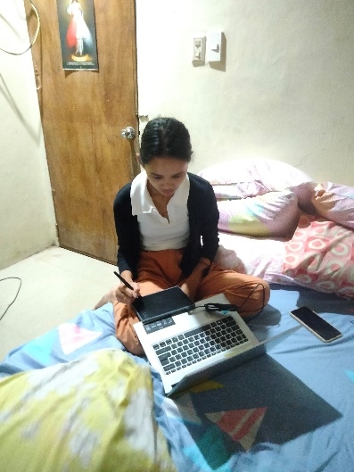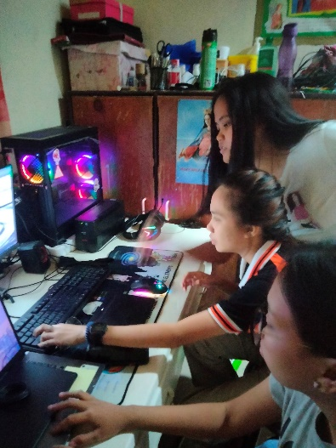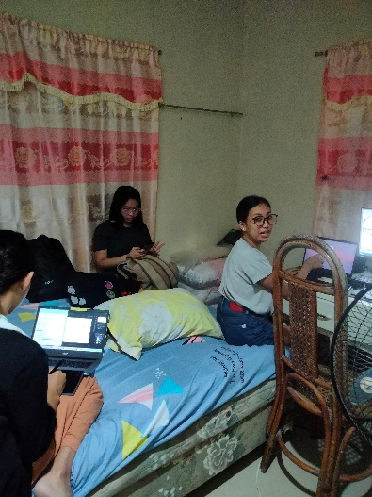

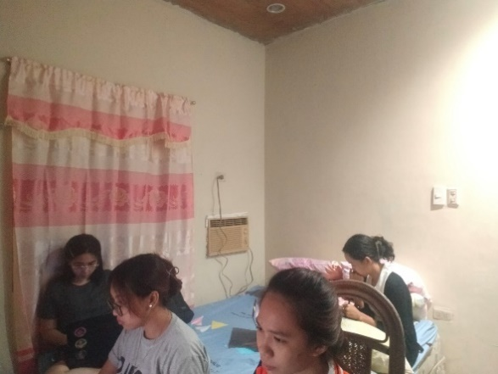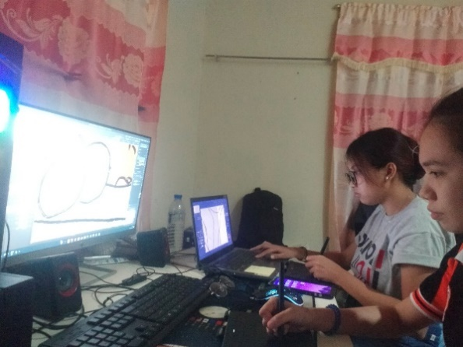

Appendix Q

Storyboard

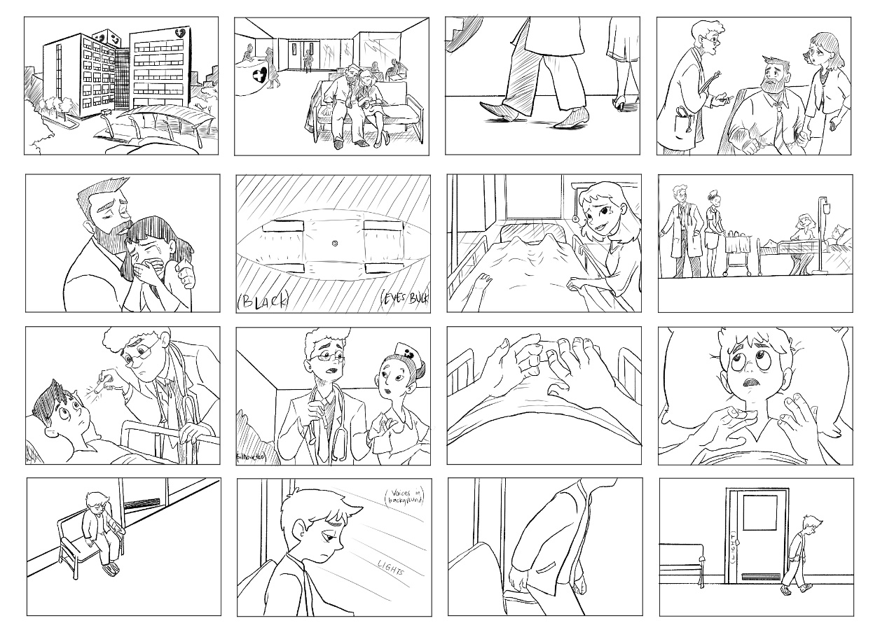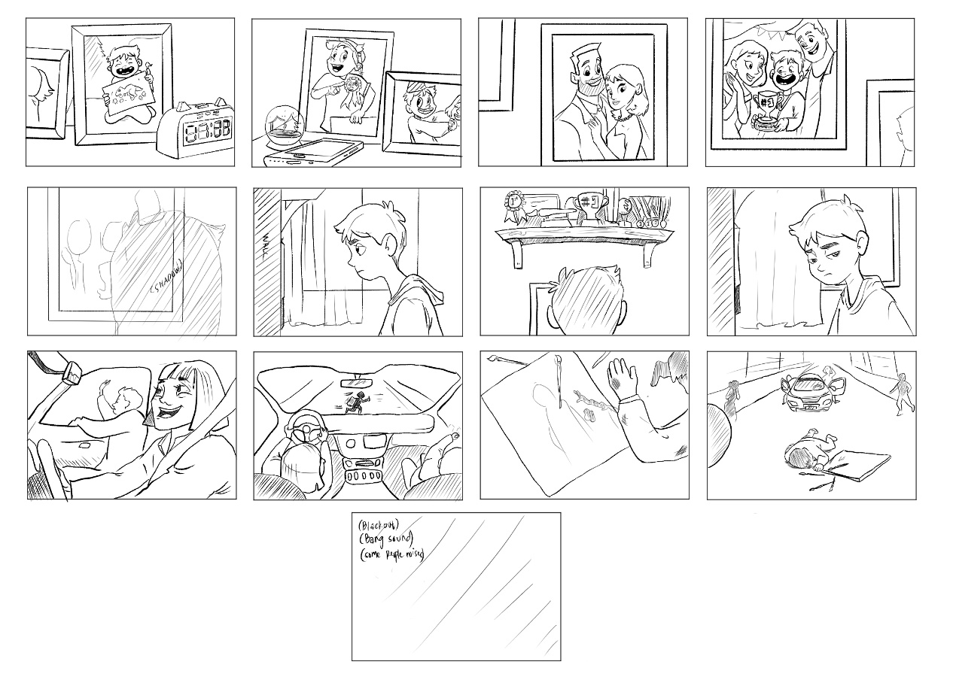

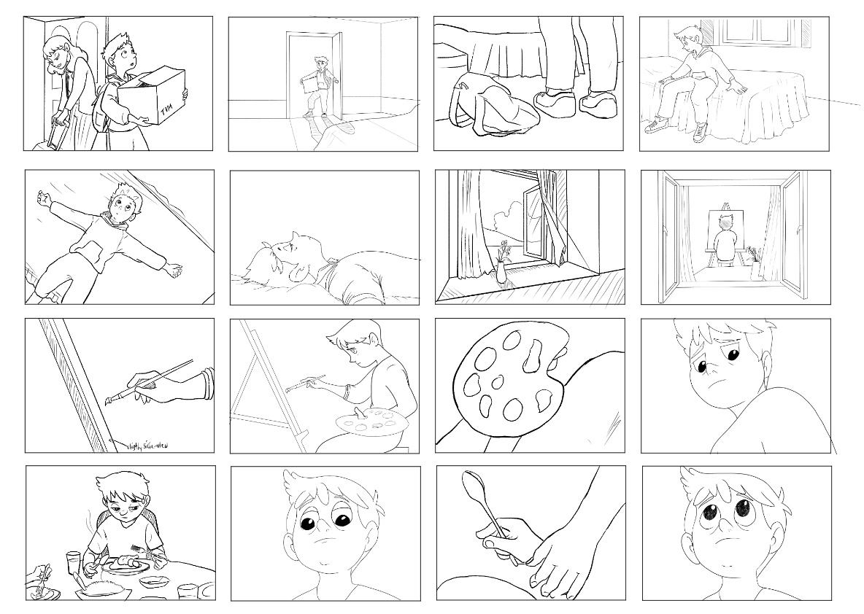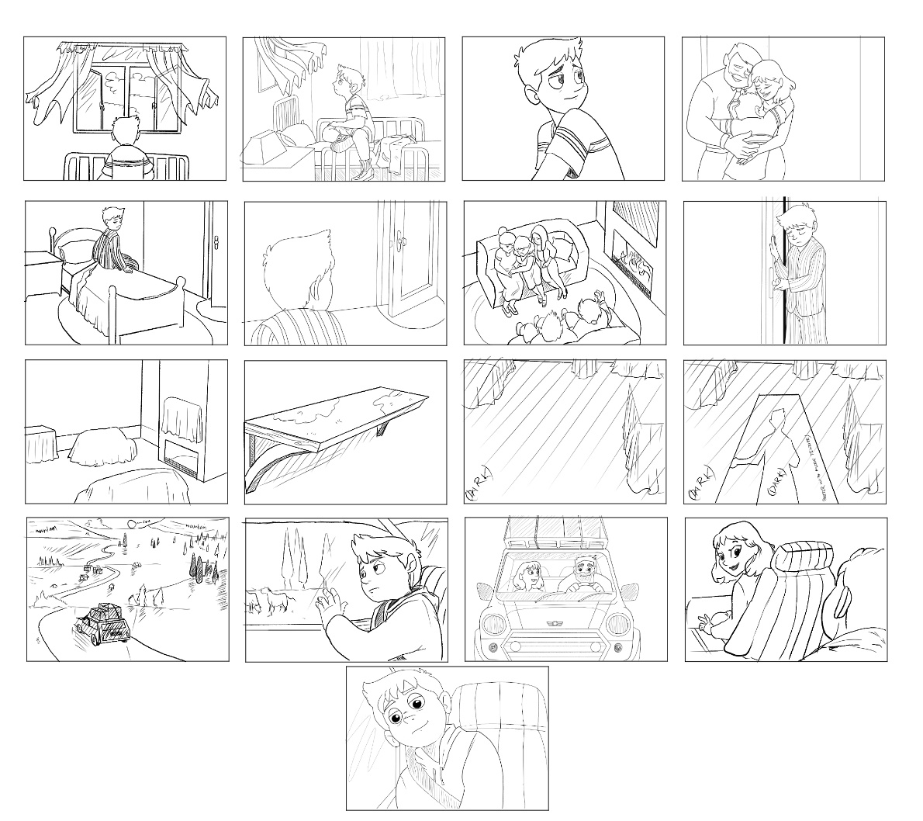

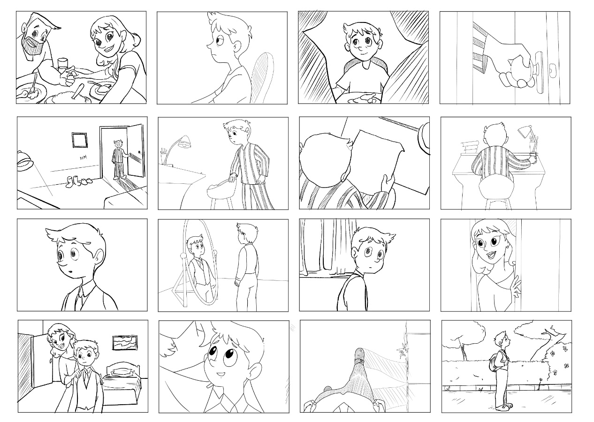

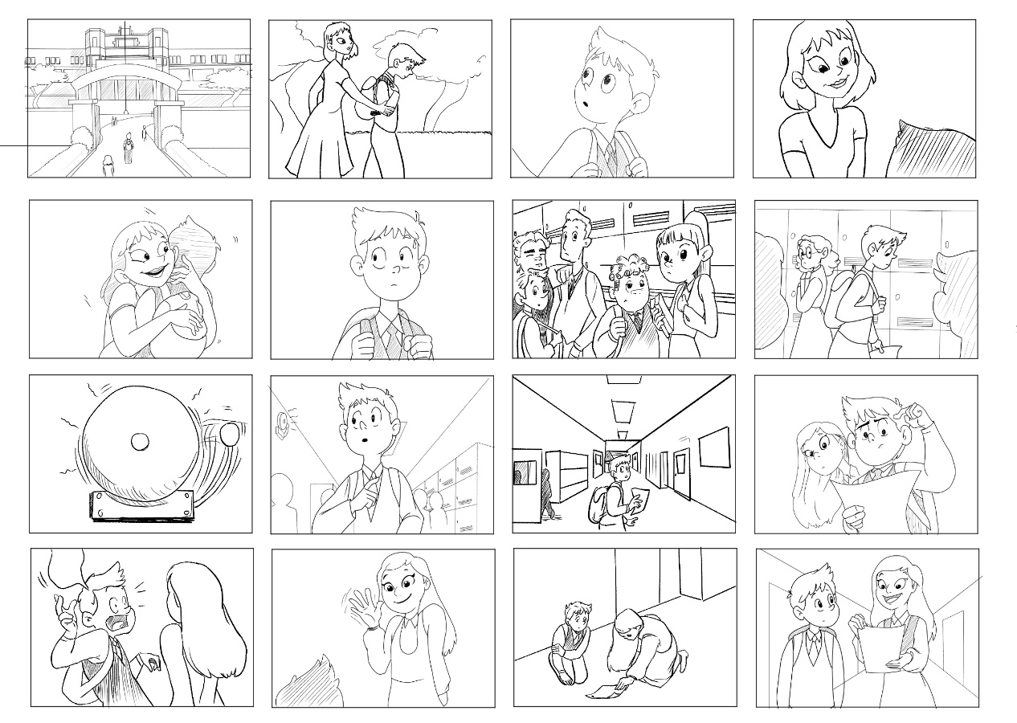

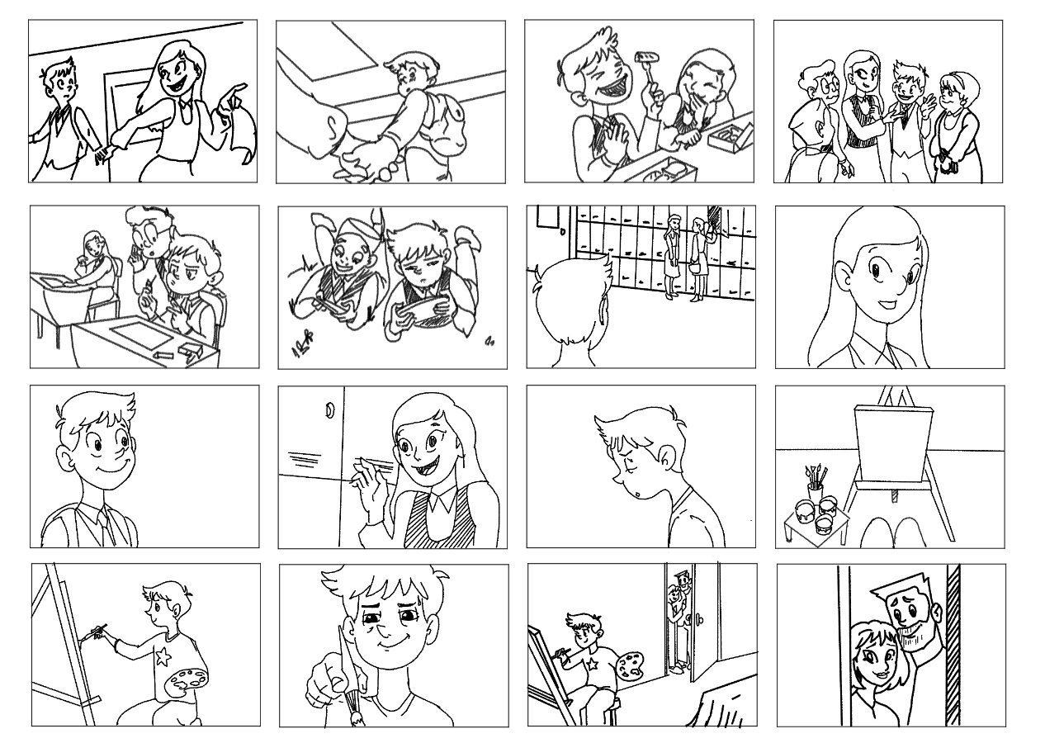

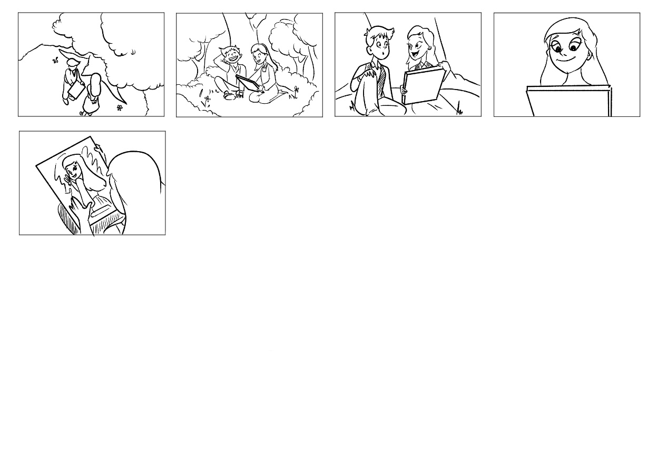

Appendix R

Disclaimer

This software project and its corresponding documentation entitled “Hues of You: A 2D Interactive Animated Short Film” is submitted to the College of Information and Communications Technology, West Visayas State University, in partial fulfillment of the requirements for the degree, Bachelor of Science in Entertainment and Multimedia Computing. It is the product of our own work, except where indicated text is.

We hereby grant the College of Information and Communications Technology permission to freely use, publish in local or international journals/conferences, reproduce, or distribute publicly the paper and electronic copies of this software project and its corresponding documentation in whole or in part, provided that we are acknowledged.

Hilary Ann P. Denura

Ma. Dyzza E. Espino

Lara Dionise Marie F. Loretizo

Nissi Joy A. Mana-ay

Winzee Dawn C. Panunciar

June 2023